**1 Lecture 1. Features of the propagation of radio waves and**

**radio system classification**

The purpose of the lecture: to consider the features of radio wave propagation and the classification of radio communication systems.

The influence of the radio wave propagation medium imposes a limitation on the wavelengths used in various radio communication systems. The influence of external factors on radio waves with different wavelengths is not equally affected. Therefore, it is advisable to consider the properties of radio waves in the ranges within which the waves exhibit approximately the same properties.

Radio Regulations - an international treaty that establishes the regulatory framework for the use of radio frequencies and satellite orbits. A Radio Regulations is being developed by the International Telecommunication Union.

The International Telecommunication Union (ITU) is the United Nations specialized body, an international organization within which governments and the private sector coordinate global telecommunication networks and services. The ITU includes: ITU-R Radiocommunication Sector (ITU-R) and Telecommunication Development Sector (ITU-D), Telecommunication Standardization Sector - ITU-T. Standards ITU-T covers almost the entire field of telecommunications.

In accordance with the Radio Regulations, it is customary to divide the radio range into separate bands, guided by the decimal principle. Figure 1 shows the frequency ranges and their applications.

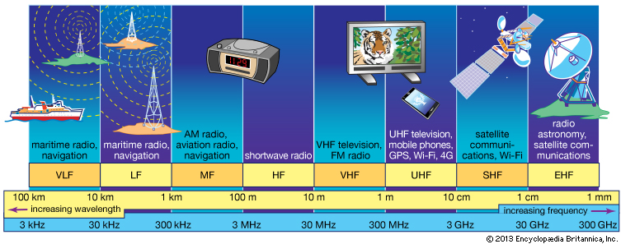

Figure 1.1 - Radio frequency ranges

An essential feature of the propagation of radio waves in terrestrial conditions is the dependence of the propagation characteristics on the wavelength. The propagation of radio waves along the earth's surface depends on its topography and physical properties. The most important electrical parameters of the soil are its electrical conductivity and permittivity. These characteristics determine the parameters of reflected and refracted waves at the interface between two media. The electrical conductivity of the soil also determines the energy loss during the propagation of waves along the Earth's surface.

An equally important influence on the propagation of radio waves in near-Earth space is played by the Earth's atmosphere (the gaseous shell of the Earth). According to the complex of physical features, the atmosphere is usually divided into three characteristic layers: the troposphere, stratosphere and ionosphere.

Figure 1.1 shows the simplified structure of the Earth’s atmosphere, and table 1.3 shows the main methods of propagation of radio waves.

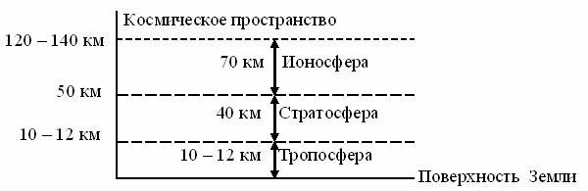

Figure 1.2 - The structure of the Earth’s atmosphere

The troposphere is the lower layer of the atmosphere, located from the surface of the Earth to heights of the order of 10 - 20 km. The properties of the troposphere are determined by a mixture of gases (nitrogen, oxygen, etc.) and water vapor. With altitude, the temperature and air pressure, as well as the water vapor content in the troposphere decreases. Thus, the troposphere is heterogeneous in its electrical properties.

The stratosphere - an atmosphere layer lying above the troposphere, extends to heights of the order of 60 - 80 km. The density of gases in the stratosphere is much lower than in the troposphere. The electrical properties of the troposphere are practically unchanged, and radio waves propagate in it in a straightforward and almost lossless manner.

The ionosphere is the upper layer of the ionized atmosphere surrounding the Earth (up to heights of the order of several thousand kilometers). Under the influence of cosmic radiation and ultraviolet rays of the sun, electrons are knocked out of the gas atoms that make up the atmosphere, resulting in the formation of positive gas ions and free electrons. Ionized gas has electrical conductivity and is able to change the propagation characteristics of electromagnetic waves. The higher the concentration of free electrons, the stronger they affect the propagation of radio waves.

Figure 1.3 shows the main propagation paths of radio signals

**УКВ**

**Ионосфера**

**КВ, СВ, ДВ**

**УКВ ,** **КВ**

**СВ, ДВ, СДВ**

**1**

**2**

**3**

**4**

**5**

**6**

*θ0*

**Мертвая зона**

**Тропосфера**

Figure 1.3 - The main modes of propagation of radio waves.

Four types of waves are distinguished by the propagation method: direct, surface (terrestrial), tropospheric and spatial (ionospheric).

Within the line of sight, signals of all ranges propagate, in Figure 1.3 line 5.

Radio waves propagating in the immediate vicinity of the Earth’s surface, partially enveloping the convexity of the globe due to diffraction, are called surface or earth waves. Figure 1.3 shows the trajectory of the surface wave of signals at medium, long, and super long waves (NE, LW, SDE) by curve 6. It is known from the physics course that diffraction is observed when the size of the obstacle is commensurate with the wavelength. In this case, the ball segment is an obstacle. The height of the latter depends on the distance between the correspondents, therefore it is clear that the longer the working wavelength, the greater the distance it can propagate due to diffraction. Diffracting around the spherical surface of the Earth, the surface wave is partially absorbed by semiconducting earth, the degree of absorption of which depends on the structure of the soil (sand, clay, stones, etc.) and its moisture content. The atmosphere of the Earth has little effect on the propagation conditions of this wave. Ranges are used in marine and terrestrial radio navigation systems.

Radio waves propagating over long distances and even enveloping the globe as a result of multiple reflections from the ionosphere and the earth's surface (in the wavelength range longer than 10 m, NE and LW ranges), are called spatial, or ionospheric waves. In Figure 1.3, curves 2.4.

Radio waves propagating over considerable distances (up to 1000 km) due to scattering on inhomogeneities of the troposphere, as well as due to the phenomenon of tropospheric refraction, are called tropospheric waves. Note that the troposphere affects only electromagnetic waves, the length of which is less than 10 m, of HF radio waves. In Figure 1.3, curve 3.

UHF, microwave and EHF radio waves propagate into outer space, bypassing the ionosphere. These radio frequency ranges are used in direct visibility radio communication systems, in satellite and space systems.

Total losses on any radio link are the sum of the main losses and additional ones. The main losses are determined by the attenuation of the signal in free space due to the divergence of the rays due to the spherical wave front. Additional losses are determined by losses in the propagation medium as a result of absorption, scattering of wave energy by the inhomogeneities of the medium, changes in the initial polarization of the wave under the influence of a magnetic field, etc.

When waves propagate shorter than 3 ... 4 cm (f> 7 ... 10 GHz) in the Earth's atmosphere, the greatest contribution is attenuation in water vapor and oxygen contained in the atmosphere and in atmospheric formations (rain, fog, wet snow).

Radio communication systems can be classified according to various criteria: by the type of transmitted messages; on the occupied spectrum of radio frequencies; by the nature of the transmitted signals; throughput, etc.

**2 Lecture 2. General principles of building RRL**

The purpose of the lecture: To study the type of RRL stations, frequency plans.

Types of RRL stations, frequency shift, multi-barreled work, span.

Radio relay communication lines are based on the principles of multiple signal relaying. There are two types of microwave links:

- tropospheric microwave links based on the principle of distant tropospheric propagation (DTR),

- direct-line radio-relay lines, which are a chain of transceiver stations located at stable communication distances within the line-of-sight of antennas (the name comes from the English “relay”).

б)

а)

20-30km (50km)

250 km

Figure 3.1- Organization Principles:

a) RRL radio-relay lines of direct visibility (RRL);

b) tropospheric radio relay lines (TRL).

 DTR occurs due to reflection and scattering of radio waves by turbulent and layered inhomogeneities of the troposphere. features, the distance between stations is chosen more often within 200 ... 400 km. Due to the significant attenuation of signals on the spans, it is necessary to significantly increase the energy potential of the system. The use of powerful transmitters, large antennas significantly reduces the possibility of using TRL. In the future, we will consider direct line of sight radio links that are widely used at present.

The combination of technical means and the medium for the propagation of radio waves to provide radio-relay communication forms a radio-relay communication line. Transceiver stations are called radio relay stations (RRS).

The line-of-sight distance (span length) is the distance between adjacent RRS, which can be determined by an approximate formula for the case of a smooth spherical earth's surface:

R0,км ≈ 3,57× (√h1 +√h2),

where h1 and h2 are the antenna suspension heights in meters.

The most common antenna mount heights are 20 ... 80m. This ensures a line of sight from 30 to 60 km.

For RRL operation in accordance with the recommendations of ITU-R F-series, frequency bands in the ranges: 7; 8; 10; 11; 12; 13; fourteen; fifteen; eighteen; 23; 27; 31; 38; 55 GHz.

Functional radio relay stations are divided into:

- terminal (OPC), carry out the input and allocation of the transmitted information of the transmitted information, and provides information distribution to consumers (telecentre, long-distance telephone exchange, company office);

- intermediate (PRS), the transmitted signals are relayed at an intermediate frequency, if necessary, it is possible to extract TV signals or part of the telephone group spectrum;

- nodal (URS), here the transmitted information is re-accepted with the ability to enter and highlight information to consumers, it also provides for branches or intersections of the RRL.

Stations are arranged in a zigzag pattern - this allows eliminating interference from stations located three to five spans with existing plans for the distribution of radio frequencies.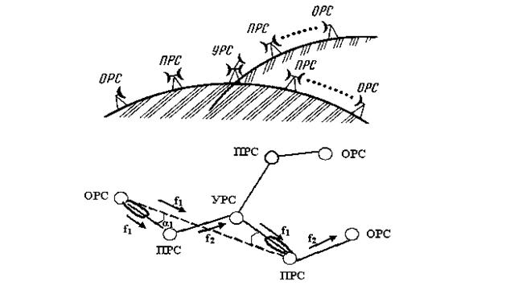

Figure 3.2 - Diagram of a radio relay communication line

Terminal stations are installed at the extreme points of the communication line and contain modulators and transmitters in the direction of signal transmission and receivers with demodulators in the direction of reception. In Figure 3.2, terminal stations are designated OPC1 and OPC4. For transmission and reception, one antenna is used, connected to the transmission and reception paths using an antenna splitter (duplexer).

Modulation and demodulation of signals is carried out at one of the standard intermediate frequencies (70 - 1000 MHz). Modems can work with transceivers using different frequency ranges. The transmitters are designed to convert the intermediate frequency signals into the microwave operating range, and the receivers are designed for the inverse conversion and amplification of the intermediate frequency signals.

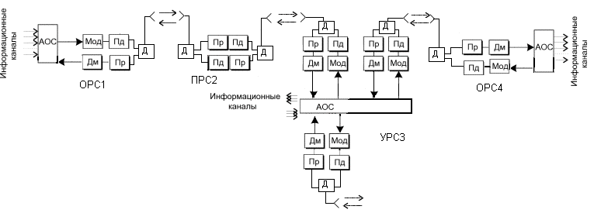

Figure 3.3 - Block diagram of a radio relay communication line

Intermediate stations are located at a line of sight and are intended for receiving signals, amplifying them and transmitting them over the communication line. Reception and transmission of signals at intermediate stations should be carried out at different frequencies to eliminate spurious connections in transceivers. The difference between the transmit and receive frequencies is called the shift frequency (fsdv) or duplex frequency spacing (FTX-RX).

Also, to eliminate the influence of the signal from the transmitter on the received signal during operation, a duplexer is installed on one antenna.

 Nodal stations perform both the functions of intermediate stations and the functions of input and output of information. Therefore, they are installed in large settlements or at the points of intersection (branch) of communication lines.

The gap between the terminal station and the nearest nodal or between nodal stations is called the RRL section or section, and the set of transceiver equipment forms the RRL trunk.

Frequency plans for RRL, designed to reduce the effect of the transmitted signal on the received, when working with one antenna on the reception and transmission, and address the issue of electromagnetic compatibility with other radio communication systems.

2-frequency and 4-frequency systems are applied.

    Figure 3.4 - Used frequency plans:

Transmission f1B

ПРС

Receiver f1H

Transmission f1B

Receiver f1H

Transmission f2B

ПРС

Receiver f2H

Transmission f2B

Receiver f2H

a) dual frequency; b) four-frequency.

The 2-frequency system (Figure 3.4 a) is economical in terms of using the frequency band, but requires the use of antennas with good protective properties (at frequencies above 10 GHz, parabolic antennas with additional screens - collars are used). On the RRL when using a two-frequency plan, there is a repetition of transmission frequencies over the span, as indicated in Figure 3.2. Moreover, in order to reduce mutual interference between RRS operating at the same frequencies, the stations are arranged in a zigzag pattern relative to the direction between points.

Moreover, if a station receives a signal at a frequency f1 and transmits at a frequency f2, then neighboring stations receive at a frequency f2, and transmit at a frequency f1. This pair of frequencies, corresponding to the ITU-R two-frequency frequency plan, forms a radio frequency trunk.

The 4-frequency system (Figure 3.4 b) allows for simpler and relatively cheap antennas, but it is rarely used, only in very complex electromagnetic environments.

To increase economic efficiency and throughput, multi-barrel radio relay systems are used, in which at each station several transceivers operate with different frequencies through a common antenna-feeder path.

Table 3.1 provides an example of carrier frequencies for RRL trunks in accordance with ITU-R Recommendation in the 17 GHz band.

ITU-R Recommendation F385

- duplex frequency spacing (Tx-Rx) 161MHz;

- spacing between the trunks 7 MHz.

Table 3.1 - Carrier frequencies for RRL trunks in accordance with ITU-R Recommendation in the 17 GHz band.

|  |  |  |
| --- | --- | --- |
| trunk | f н, MHz | f в, MHz |
| 1 | 17428 | 17589 |
| 2 | 17435 | 17596 |
| 3 | 17442 | 17603 |
| 4 | 17449 | 17610 |
| 5 | 17456 | 17617 |
| … | … | … |
| 19 | 17554 | 17715 |
| 20 | 17561 | 17722 |

Each trunk of the station has a standard designation, for example: 2ВН, where 2 is the trunk number, В- means reception at the upper frequency, Н- transmission (radiation) at the lower frequency. A set of equipment on the other side of the span will have the designation 2HB, respectively.

When combined to work on one antenna, the odd or even trunks are combined, in order to increase the difference between the frequencies of the combined trunks.

Modern systems use flexible frequency plans. The separation of the frequency channels in such cases is determined by the throughput (the speed of the DRL) and the type of modulation. Most often, the working frequency spacing is 3.5; 7; 14 or 28 MHz.

In order to increase the reliability of communication lines, various redundancy methods n + 1 are used. Where n is the number of workstations for which 1 standby trunk is used. The number of redundant shafts may vary depending on the reliability requirements of the transmission system. Often simple single-barrel communication systems without redundancy are built, given the high reliability of modern equipment.

**Lecture 3. Principles of radio relay station equipment construction**

The purpose of the lecture: to consider the structural schemes of the RRS, the purpose of the external and internal blocks.

The large and medium capacity RRL transceiver equipment is equally suitable for transmitting multichannel telephony signals and transmitting television signals. Only the terminal equipment of telephone and television trunks is different.

Modern microwave equipment very often consists of indoor and outdoor modules connected by one or more cables. Cable lengths can be several hundred meters.

Internal module, access node containing input and output interfaces for source digital streams, modems and monitoring and control devices. The input and output interfaces can be electrical (EI) or optical (OI), and some types of equipment contain both interfaces or they are installed on request.

In the interfaces, the signals received via cables from the equipment for multiplexing digital streams are matched, the codes are converted (quasi-ternary to NRZ and vice versa) and the clock frequency is allocated (in input devices).

The main signal processing before modulation and after demodulation is carried out in the respective digital processors.

 In the transmitting part of the internal module, the digital processor performs the following operations:

interleaving of code sequences (to protect against long packet errors);

Error Correction (FEC) using convolutional or block correction codes;

scrambling (to improve the statistical properties of digital signals);

the formation of digital streams in-phase (I) and quadrature (Q) channels for subsequent multilevel modulation.

In a digital-to-analog converter (DAC), multi-level signals are generated from the digital streams of I and Q channels in accordance with the applied modulation type. For example, with 4FM modulation, 2-level signals are used, and with 16KAM - four-level signals. These signals enter the modulator (MD), where they control the oscillations of the intermediate frequency. The service signal modulator (MDSS) adds to the traffic signal service signals allocated in the external unit, necessary to control its operation.

The modulated intermediate frequency signal passes through a coaxial cable to an external unit through a filtering device (UV). Previously, the intermediate frequency signal is additionally modulated by various overhead information and digital system control data.

In the receiving part of the internal module, operations are performed that are opposite to those performed in the transmitting part. The input signal of the receiving part receives an intermediate frequency signal from an external unit via a coaxial cable. To eliminate mutual influences in the cable, the signals of the intermediate frequency of transmission and reception are selected different (for transmission - 300 - 800 MHz, for reception, most often, 70 MHz).

The central core and the braid of the same cable are supplied with power (20 - 80 V DC) to the external equipment module.

The external module contains a transmitter and a receiver and is mounted on the antenna mount in the immediate vicinity of the antenna or docked to it.

The transmitter converts the intermediate frequency signal into the operating frequency range and provides the necessary output radiation power. In this example of a structural diagram, the transmitter path begins with a service communication demodulator, in which signals are allocated to control the operation of an external module and control its parameters. The main intermediate frequency signal is fed through a powerful IF amplifier (MUCH) to the input of a frequency converter, consisting of a mixer (SM) and a master oscillator. Oscillations of the master oscillator are formed in the block of heterodyne frequencies.

The signal obtained during the conversion process, consisting of the carrier frequency of the master oscillator and two side bands, is fed through a band-pass filter (PF) to the microwave amplification unit (UHF). The bandpass filter extracts one of the sidebands from the converted signal. Typically, in modern equipment, a controlled attenuator is installed in front of the UHF, designed to control the radiated power of the transmitter. Often this attenuator provides the adaptive power control system of the transmitter (ARMP), depending on the propagation conditions of the signal on the track.

To improve the linearity of the amplitude characteristic of the transmitter, distortion compensators for the third harmonic are used, which can be installed in the IF path (PsK) or in the microwave path (LNZ).

 The signal from the output of the transmitter passes to the antenna through blocks of separation filters (RF), performing the following functions:

- Separation of signals of different radio frequencies during multilateral operation;

- ensuring the operation of receivers and transmitters through one antenna;

- separation of signals of different polarizations with co-channel frequency plans;

- Ensuring harmonization of receivers, transmitters and antennas.

The receiver converts the signal from the operating frequency range to the intermediate frequency and amplifies this signal to the desired level.



Figure 4.2 - NEC PASOLINK outdoor unit

Figure 4.2 shows the Pasolink radio relay outdoor unit. The parabolic antenna has a diameter of 45 cm and is connected to the transceiver unit directly without a waveguide. Elements for mounting the module to the antenna mount are located on the antenna unit and have alignment devices in the vertical and horizontal planes. The transmitter-receiver unit can be easily disconnected from the antenna unit for replacement, adjustment and maintenance. Larger diameter antennas (0.6 and 1.2 m) can be connected to the transceiver.

The external unit is connected to the indoor unit located in the room with a coaxial cable. Modern modem equipment is an easily transforming complex that operates under the control of a central or local computer.

.

The internal unit (IDU) contains the baseband signal processing units, including multiplexing, switching, and all user interfaces.

An example of the spectrum of a group signal of a telephone trunk is shown in Figure 4.4.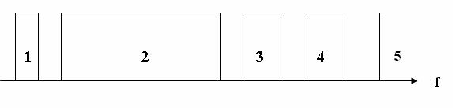

Figure 4.4 - Linear spectrum of a group signal of a telephone trunk:

1 - CC (intercom signals, in the lower part of the group spectrum a separate narrow-band channel); 2 - MTFS (multi-channel telephone message); 3, 4 - SZV1, SZV2 (sound broadcasting signals 1, 2);

5 - PS (pilot signal); f is the frequency

Pilot signal - allows you to control the acceptable signal level when deciding on the use of a backup channel.

**Lecture 4. RRL design. Determination of heights of antenna supports**

The purpose of the lecture: to consider the stages of RRL design, to make a reasonable choice of technical characteristics of RRL equipment

The construction of a line-of-sight RRL begins with the design of a communication line.

Design can be divided into the following stages:

1) determination of operating frequencies (permission, EMC assessment);

2) route selection (station locations, terrain accounting, availability of power supply, etc.).);

3) determination of the height of the antenna suspension (construction of the span profile);

4) equipment selection (technical specifications, maintenance);

5) check the stability of communication (implementation of standards for errors);

6) analysis of the results.

If the project is approved by the customer proceed to the installation of equipment and commissioning.

The frequency of the signal determines the maximum span that can be achieved when the transmitter power is limited. The higher the frequency, the greater the attenuation in free space and the effect of rain on the propagation of the radio signal.

Currently, the following frequency bands are widely used for RRL:

7-8 GHz (the average length of the span of RRL is 30-40 km, the antennas have a high gain with diameters of about 1.5-2.5 m, weak influence of hydrometeors (rain, snow, fog, etc.), but in this frequency range is a very complex electromagnetic environment, there are many RRL and difficult to obtain permission for these frequencies);

10.7-11.7, 12.7-13.2 GHz (span length of 15-30 km, antenna have small dimensions (0.6 m) and weight, which provides a relatively inexpensive antenna supports, increasing the impact of the hydrometeors, adverse pleasant electromagnetic environment);

14.5-15.35, 17.7-19.7 GHz (span length reaches 20 km, typical parabolic antennas have diameters of 0.45; 0.6, the propagation of signals is strongly influenced by hydrometeors, electromagnetic environment is calm). The attenuation in rain can be 1-12 dB / km at a rainfall intensity of 20-160 mm / h.

21.2-23.6 GHz 25.25-27.5 GHz (average span 15 km, antennas have a diameter of 0.3; 0.6 m, attenuation in the rain 3-24 dB / km, range zones are allowed to be used in satellite communication systems, so the calculations must take into account the possibility of interference).

The frequencies above are rarely used, as the span length is not more than 10-12 km and strong attenuation in hydrometeors and atmosphere.

Taking into account the above information, the operating frequencies of the equipment are selected and, knowing the average length of the span, the locations of the station are selected on a topographic map. The masts on which the antennas will be placed are placed on the hills, so that there are no obstacles (hills, buildings, forest) within the line of sight of the neighboring stations.

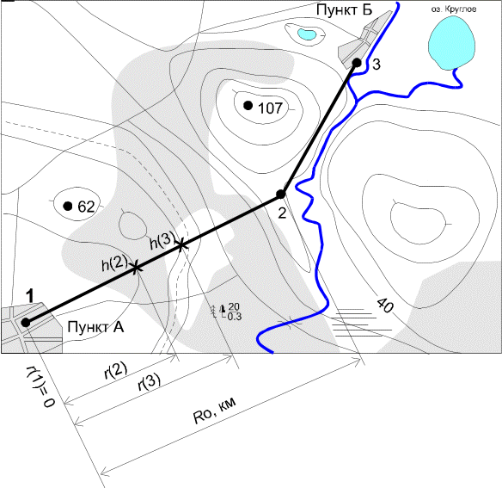

Figure 5.1-RRL Route on the topographic map

The main part of the transmitter energy is distributed in the direction of the receiving antenna within the minimum Fresnel zone, which is an ellipsoid of rotation, at the edges of the major axis of which the transmitting and receiving antennas are installed. The radius of the minimum Fresnel zone at any point of the span can be determined by the formula:

,m (5.1)

where - is the relative coordinate of the highest elevation point on the span;

R0-span length, m;

λ-wavelength, m;

Rj - distance to the obstacle point, m.

In the atmosphere, due to its inhomogeneous structure and the change in the refractive index with height, the curvature of the trajectories of radio waves occurs, called refraction. The phenomenon of refraction has a significant impact on the propagation of radio waves within the line of sight of RRL antennas. The nature of refraction in spherical-layered planetary atmospheres is determined by the altitude gradient of the refractive index of the atmosphere, which is defined as g= dN/dh, where N is the refractive index of the atmosphere.

Random changes in the vertical gradient of the refractive index of the atmosphere lead to the curvature of the trajectory of the radio beam, which in some cases may touch the earth's surface, and thus there are diffraction effects that reduce the level of the received signal. Due to ground obstacles, even complete loss of mutual visibility of antennas (lack of communication) is possible.

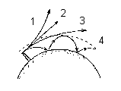

Figure 5.2-radio beam trajectories at different refraction:

1) g>0 negative refraction; 2) g=0 no refraction;

3); g<0 positive refraction

4) the emergence of the Earth - ionosphere waveguide channel.

Therefore, when designing the RRL, it is important to ensure sufficient clearance of the route by selecting the heights of the antenna suspension.

Span refers to the crossed, if the height of the earth's surface irregularities Δhj ≥ 2H0.

0

2

4

6

8

10

12

14

16

R, км

h2, м

h1,м

H0

ΔH(g+σ)

Zj

Y

S

M

O

D

C

R0, км

Rj, км

A1

A2

rП

Figure 5.2-RRL flight Profile (vertical section of the terrain passing through the antenna installation sites)

The following designations were adopted:

A1, A2-receiving and transmitting antennas RRL;

h1,h2 – the height of the suspension antennas;

CD, MO, SY-elevation of the terrain;

M-critical point (top of the obstacle);

Zj – the real curvature of the Earth, which can be determined by the approximate formula

,m (5.2)

where R0 – span length, km;

a = 6370 km-radius of the Earth;

H(0) - clearance on the span in the absence of refraction, m;

ΔH (ĝ+σ) - the average value of the change in the lumen due to refraction, existing for 80% of the time (ĝ, σ-respectively, the average value and standard deviation of the vertical gradient of the dielectric permittivity of the troposphere), m;

H (ĝ +σ) - the gap in the span, existing for 80% of the time, which is usually chosen to be H0.

m (5.3) m.            (5.4)

After selecting the radio path and the locations of antenna supports, building a profile of the span taking into account the relief and curvature of the earth. Taking into account by examining the terrain, the height of vegetation and buildings, you can begin to determine the height of the suspension antennas. Additional constructions are performed on the calculated values of H0 , and H (0).

On the profile of the flight from the critical point M is postponed to the scale value H(0) and through the upper point of the segment H (0) spend the beam connecting the antenna.

The height of the antenna suspension is determined by formulas, if the beam passes horizontally, in cases of complex terrain, the height of the antenna suspension is determined by the figure in accordance with the scale.

h1 = ON+OM+H(0) – CD, m, (5.5)

h2 = ON+OM+H(0) – SY m (5.6)

The calculation of the suspension height of the antennas except the few exceptions are common for both analogue and digital radio relay lines. For radio relay line of sight defined criteria for the quality of communication in accordance with the rules of ITU-R. design Tasks – to check the conformity of parameters of the designed RL these criteria.

**Lecture 5. Calculation of communication stability for digital RRL**

The purpose of the lecture: to get acquainted with the method of calculating the stability of digital RRL.

Error quality indicators (BER) and availability indicators (ar availability factor) are commonly used as setting parameters when designing digital rrls. The use of a quality indicator depends on the length of downtime:

- when downtime is less than 10s, the cause of fading is multipath propagation and the standards used in this case are error quality indicators (more stringent);

- with a longer duration of downtime (causes: rain, equipment failures) use standards for readiness (softer).

As a rule, manufacturers of RRL equipment set the value of the threshold signal power at the input of the receiver Rprm.min at BER=10ⁿ (n=-5 and n=-6).

The readiness factor (AR) is defined as the proportion of time that a tract is ready during the observation period (for example, 1 year). Another value is the unavailability factor (UR), with AR+UR=1.

The total availability factor is

AR=1 - [(T1+T2-TV) / TE], (6.1)

where T1 and T2 are the time of unavailability in one and the other direction;

TV-time of unavailability for both directions simultaneously;

Te-evaluation time period (≥1 year).

In accordance with ITU recommendations, the standards for the availability of high-quality digital RRL (GEC - length 2500km) are set in the range of 99.5-99.9%. In practice, the value of 99.7% is often used, the unavailability will be 0.3%. Linear extrapolation is used to determine the unavailability factor for shorter lines. For example, for a 250km line UR=0.03%.

The fading reserve characterizes the ability of the system to maintain the required level of the received signal when the signal propagation conditions deteriorate during the RRL flight.

*Ft = SG+GПРД+ GПРМ –L0-2η,* dB, (6.2)  
where SG-coefficient of the system, dB;

*η*-signal attenuation in antenna-feeder path (2*η* ≈5dB);

Lo-attenuation of radio waves in free space, dB;

GПРД, GПРМ -gain transmitting and receiving antennas, respectively, dB.

Attenuation of the signal in the path of radio waves in dB

image052 ,

(6.3)

where *LДОП* -additional signal attenuation due to inhomogeneities of the real propagation medium (accounting for attenuation in gases, water vapor contained in the atmosphere).

Attenuation in free space is determined by taking into account the wavelength and span length according to the following formula:

 дБ, (6.4)

where λ is the wavelength, m.

Since radio relay systems most often use parabolic mirror antennas, the antenna gain is determined by:

**, db

(6.5)

where q is the utilization factor of the antenna opening (0.7-0.9);  
DA-antenna diameter, m.

If the antenna suspension heights are chosen correctly, then the link stability is evaluated by performing an inequality

image040  (6.6)

T∑ - the total probability (percentage of time) of deterioration of communication quality due to deep fading of the signal for the entire route crrl,

ТДОП- allowable probability of deterioration this DRRL in accordance with the regulations. We consider this question for one span, as for RRL consisting of n spans the probability of deterioration of communication quality is determined respectively, where n is the number of spans.

The total likelihood of deterioration of communication quality on the RRL due to the deep fading of the signal at one of the bays is determined by three factors: the screening obstacles, the minimum Fresnel zone t0, the interference at the point of receiving the direct ray and rays reflected from stratified inhomogeneities in the troposphere TINT, attenuation due to rain etc.

, %  (6.7)

Each of the terms in the formula is determined on the basis of relevant ITU Recommendations based on statistics specific to different climatic regions.

The time of deterioration of communication caused by subrefraction of radio waves is carried out according to the following procedure for each flight.

The average value of the lumen on the span is determined:

H(g)=H(0)+DH(g) = H(0)-(Ro2/4)*g*k*(1-k), m

The relative lumen:

P(g)= H(g)/Ho

To determine the width of the obstacle on the span profile, a straight parallel radio beam is carried out at a distance of Du = H0 from the top of the obstacle and the distance between the points of intersection of this line and the relief determines the rP , km as shown in figure 5.2. Then the relative radius of the obstacle is calculated

I= rP /R0 .

The parameter μ, characterizing the sphere approximating the obstacle is calculated by the formula:



where l- is the obstacle radius, m;

- the relative coordinate of the highest point of relief on the span.  
 The value of the relative lumen P (g0), at which deep fading of the signal occurs, caused by screening the obstacle of the minimum Fresnel zone:  
  
R(g0)= (V0-Vmin)/V0 ,

where V0 is the minimum attenuation factor at H (0)=0, determined from figure 2.15 /1/ by the known value of m ;  
 Vmin = - Ft /2 -the minimum allowable attenuation factor, dB.

Then the coefficient A (6.8) and parameter y (6.9) are calculated):  
  
 (6.8)



Parameter ψ :  
ψ = 2,31А(р(g)-p(g0)). (6.9)

According to the graph figure 2.16 / 1 / is determined by the То(ψ), %.  
Consider the second term in the formula (6.7) the percentage of time of bond instability due to fading due to multipath propagation of Тинт.

 , %

where Ft-fading margin (6.2), dB;

R0-span length, km;

f-frequency, GHz;

K-coefficient, taking into account the influence of climate and terrain;

Q-coefficient that takes into account the slope of the radio path;

B=0.89; C=3.6-coefficients taking into account regional effects, according To recommendation P. 530 ITU-R for Kazakhstan.

The pH values represent the percentage of time with a vertical refractive gradient *dN/dh* ≤ -100 N -units / km. According to ITU-R Recommendation P. 453 for Kazakhstan .

The CLat and CLot coefficients for Kazakhstan are 0.

;

where - slope of the radio path, mrad,

h1, h2-antenna suspension heights, m.

Calculation of the time of deterioration of communication due to rain.

According to ITU Recommendations the territory of the globe is divided into 16 climatic zones according to the average intensity of rains. Zones are indicated by Latin letters. Kazakhstan belongs to zone E, for which the intensity of precipitation (exceeded for 0.01% of the time) R0,01 = 22 mm/h.

To estimate the attenuation of the signal in the rain, the effective length of the rain path is calculated:

dЭ = r∙Ro, km  
where r=1/[1+(R0/d0)]- velocity factor,  
 d0 = 35∙ exp(-0,015∙R0,01)- reference distance.

Attenuation of electromagnetic waves in the rain depends on the frequency and polarization of the signal, linear attenuation in the rain is determined by the formulas:  
γV = kV *R0.01 αV,db/km;

γН = kН *R0.01 αН , db/km,

where α and k - regression coefficients for horizontal (H) and vertical (V) polarization.  
  
Regression coefficients are given in reference tables for different frequencies. The attenuation on the trace that is exceeded for 0.01% of the time is defined by the expression:  
A0,01 = γ ∙ dЭ , db.

The attenuation that is exceeded for another percentage of time T in the range 0.001-1% can be determined from the equation:

AT /A 0,01=0,12∙T[exp(-0,546-0,043∙lgT)]. (6.10)

Based on this equation, we obtain an expression to determine the percentage of time of bond instability due to rain



If A 0,01/Ft <0,154023, to obtain the actual value must be taken As 0,01/Ft = 0,155.

After calculating T∑ according to formula 6.7, this value is compared with the allowable percentage of the bond instability time, which is determined by the formula:

 (6.12)

where L is the length of the RRL route in km;

2500 km- is the length of the hypothetical reference RRL line.

 (6.13)

If the inequality 6.13 is satisfied, the communication on the radio relay line is stable and the design is carried out correctly. If the inequality does not hold, then the communication on the radio relay line is not stable.

It is necessary to analyze and identify the reason for the communication failures and make changes to the project that eliminate this reason.

To reduce the impact of rain, you can change the frequency range, that is, use a frequency lower than it was. But this is difficult, since the frequencies are allocated taking into account the electromagnetic situation in the design area and it is sometimes impossible to obtain other frequencies. In this case, it is necessary to either reduce the length of the span, or increase the diameter of the antennas, which will improve the energy characteristics of the span.

Changing the height of the antenna suspension will reduce the impact of interference and subrefraction.

**Lecture 6. Hierarchies of digital signals. Methods of modulation, coding and signal processing in digital RRL**

The purpose of the lecture: to consider the hierarchy of digital signals. Methods of modulation, coding and signal processing in digital RRL .

Hierarchy of digital signals. Synchronous Digital Hierarchy (SCI: eng. SDH-Synchronous Digital Hierarchy) is a technology of transport telecommunication networks. The standards define the characteristics of digital signals, including the structure of frames (cycles), multiplexing method, hierarchy of digital speeds and code patterns of interfaces.

Interface standardization determines the ability to connect different equipment from different manufacturers. The SDH system provides universal standards for network node interfaces, including standards at the digital speed level, frame structure, multiplexing method, line interfaces, monitoring and control. Therefore, SDH equipment from different manufacturers can be easily connected and installed in one line, which best demonstrates system compatibility.

The SDH system provides standard levels of information structures, that is, a set of standard speeds. The base rate is STM-1 155.52 Mbit/s.the Digital rates of the higher levels are determined by multiplying the STM-1 flow rate by 4, 16, 64, and so on, respectively: 622 Mbit/s (STM-4), 2.5 Gbit/s (STM-16), 10 Gbit/s (STM-64), and 40 Gbit / s (STM-256).

Linear (optical) interfaces operate using universal standards. The linear signal is only scrambled (scrambled (eng.))- encrypted, there is no excess code insertion. The scrambling standard is universal. Therefore, both receive and transmit should use standard scrambler and descrambler. The purpose of scrambling is to make the probability of a "1" bit and a "0" bit close to 50% to facilitate the extraction of the clock signal from the line signal. Since the line signal is only scrambled, the line rate of the SDH signal corresponds to the standard signal rate on the SDH electrical interface. Thus, the optical power consumption of transmitting lasers remains unchanged, however, their heat dissipation is reduced (since the possibility of following a large number of "1" in a row is excluded), which increases their resource. Another reason why scrambling is used is a long sequence of "1" ("0") automatic gain control loop is perceived as increasing (decreasing) the input signal level, which can lead to incorrect gain control.

All information in the SDH system is transmitted in containers. A container is structured data that is transferred in the system. If the PDH system generates traffic to be transmitted over the SDH system, the PDH data is first structured into containers, and then a header and pointers are added to the container, resulting in a synchronous STM-1 transport module. Over the network, STM-1 containers are transmitted in the SDH system of different levels (STM-n), but in all cases, the disbanded STM-1 can only stack with another transport module, i.e. there is multiplexing of transport modules.

Plesiochronous digital hierarchy (PDH, Plesiochronous Digital Hierarchy) is a digital method of data and voice transmission based on time division of the channel and pulse code modulation (PCM) signal representation technology.

In technology, the PDH is input signal the basics-tion digital channel (BCC), and the output forms the data stream with the speed of n × 64 kbit/s. To the group of proteins that carry a payload, are added auxiliary group of bits needed to implement the procedures of synchronization and phasing, error control (CRC), with the result that the group becomes a cycle.

In the early 80's was developed 3 such system (in Europe, North America and Japan). Despite the same principles, the systems used different multiplexing factors at different levels of hierarchies. A description of the interfaces and multiplexing levels is given in recommendation G. 703.

Table 7.1-Multiplexing Levels

|  |  |  |  |  |  |  |  |  |  |
| --- | --- | --- | --- | --- | --- | --- | --- | --- | --- |
| Уровень цифровой иерархии | Американский стандарт (Tx) | | | Японский стандарт (DSx) Jx | | | Европейский стандарт (Ex) | | |
| Обозначения | Скорости передачи, кбит/с | Количество каналов по 64 кбит/с | Обозначения | Скорости передачи, кбит/с | Количество каналов по 64 кбит/с | Обозначения | Скорости передачи, кбит/с | Количество каналов по 64 кбит/с |
| 1, первичный | T1 | 1544 | 24 | DS1, J1 | 1544 | 24 | E1 | 2048 | 30 |
| 2, вторичный | T2 | 6312 | 96 | DS2, J2 | 6312 | 96 | E2 | 8448 | 120 |
| 3, третичный | T3 | 44736 | 672 | DS3, J3 | 32064 | 480 | E3 | 34368 | 480 |
| 4, четвертичный | T4 | 274176 | 4032 | DS4, J4 | 97728 | 1440 | E4 | 139264 | 1920 |

In digital systems, a discrete change in the control oscillation modulated parameters of the carrier will change abruptly. In this case, instead of the term "modulation", the term "manipulation" is used, and the oscillation itself is called manipulated.

Amplitude-manipulated signal has the form of a sequence of radio pulses with a rectangular envelope figure 7. 1 (a).

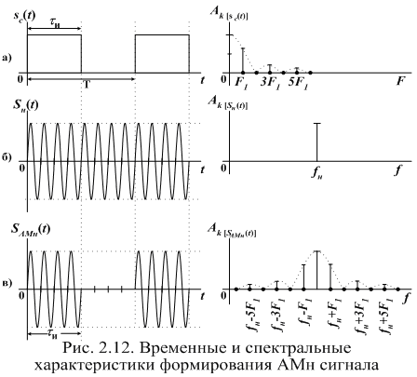

b)

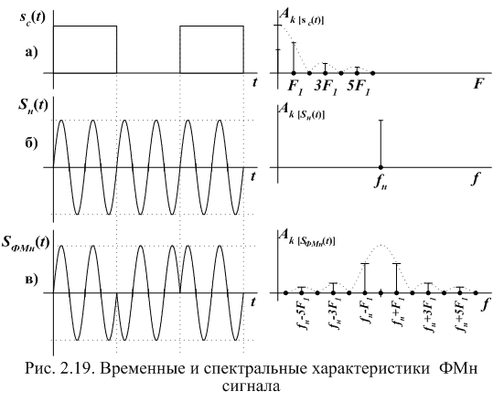

Figure 7.1-Time and spectral characteristics of the formation: a) AM signal; b) FM signal

The simplest is the binary FMN (PSK-phase Shift Keying), in which the phase change of the carrier oscillation occurs in a jump at certain moments of the primary signal at 0 or 180o; while its amplitude and frequency of the carrier remain unchanged. The time charts are shown in figure 7.1.

Distinguish FSK: with gap phases without gap phases. A General view of the FM signal with phase discontinuity can be represented as the sum of two AM signals with different carrier frequenciesimage003 and image004 . Technically, this type of manipulation is realized with the help of two generators, which are controlled by a key under the influence of an information signal. The formation of the FM signal with phase discontinuity is shown in figure 7.2 (b).

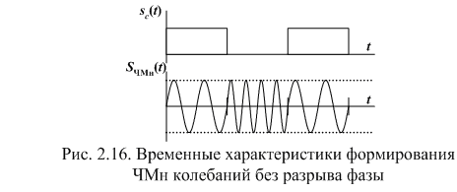

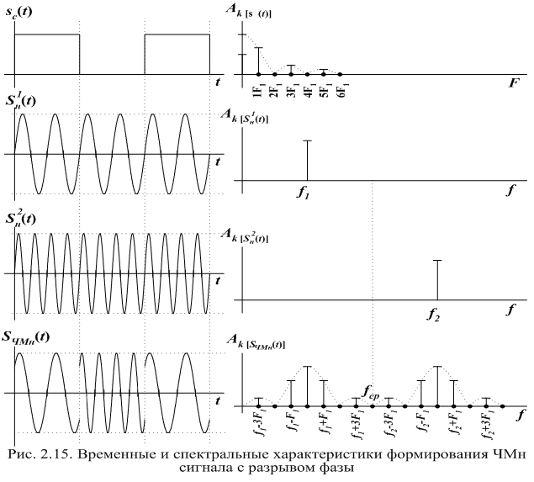

Figure 7.2-Time characteristics of FM signal generation:

without gap phases; b) break phase

Quadrature amplitude manipulation (QAM, eng. Quadrature amplitude modulation (QAM) — manipulation, which changes both the phase and the amplitude of the signal, which allows you to increase the amount of information transmitted by one state (readout) of the signal.

Formation of M-level QAM radio signal can be realized by m - level balanced amplitude manipulation of quadrature oscillations of one frequency and addition of the received AM radio signals. The most common 16-level QAM. Possible variants of the QAM-16 are shown in figure 7.3. Figure 7.3 shows the number of possible values of the amplitude of the radio signal QAM-16 is 3, and the phase 12. QAM allows you to maximize the use of bandwidth.

[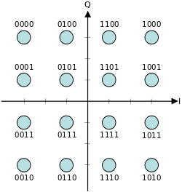](http://ru.wikipedia.org/wiki/%D0%A4%D0%B0%D0%B9%D0%BB:16QAM_Gray_Coded.svg)

Figure 7.3-signal constellation of 16-position QAM signal

**Lecture 7. Satellite communications systems; basic principles of construction; orbit parameters; types of orbits**

The purpose of the lecture: to get acquainted with the principles of building satellite communications systems.

The principle of organizing a satellite communication and broadcasting system is quite simple: with the help of a booster rocket an artificial satellite (AES) is launched into a given orbit around the Earth, on board of which a transceiver (radio relay) is placed, earth stations (AP) with parabolic antennas are installed on the Earth and with devices for continuous guidance on the satellite antenna. Signals at fixed frequencies sent from an earth station are received and amplified by an artificial satellite radio relay and, after being converted to other frequencies, are emitted by an artificial satellite antenna in the direction of the correspondent earth stations, where they are received, amplified and converted until a message is highlighted. A simplified satellite communication line is shown in Figure 8.1.

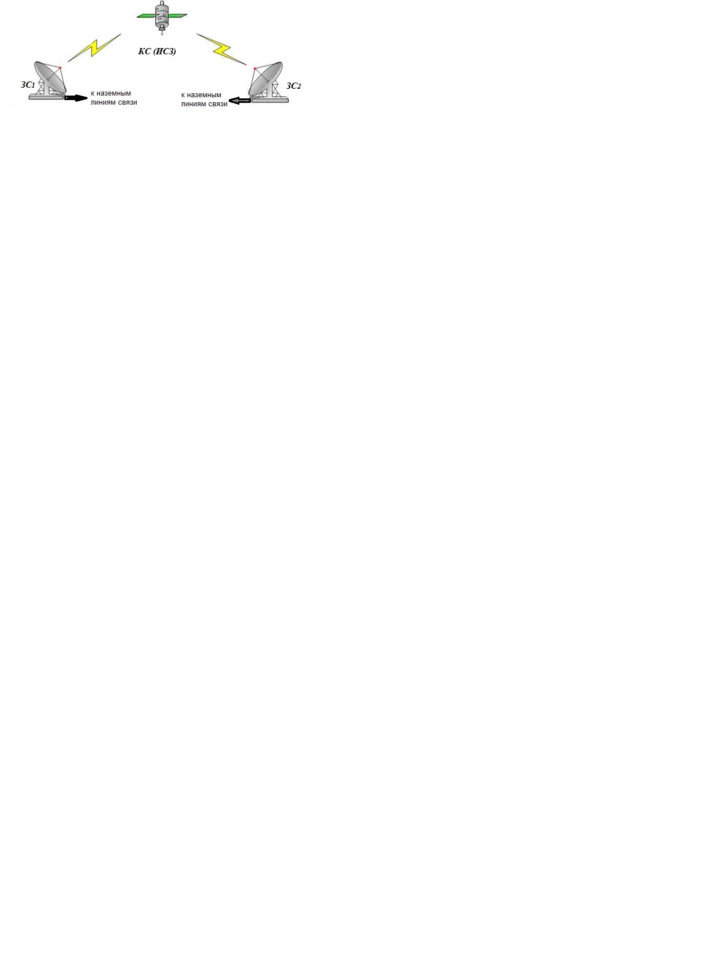

Figure 8.1 - Satellite communication line

The main components of a satellite communications system:

- the space segment of the satellite communications system consists of satellites and ground equipment, providing the functions of tracking, telemetry and transmission of telecommands (TTC) and the material and technical supply of satellites.

- earth segment. The term "earth segment" refers to the part of a satellite communications system that is formed by earth stations used to transmit and receive any kind of communications traffic signals transmitted to and from the satellite and forming a junction with terrestrial networks.

Often in satellite systems there is a subscriber segment formed by equipment designed for direct reception of SS signals by consumers of transmitted information. For example, automobile satellite terminals, telephones, individual satellite television receivers, etc.

The configuration of SS systems depends on the type of artificial Earth satellite, the type of communication and the parameters of earth stations. For the construction of SS systems, the satellite is mainly used, orbits are located at different heights. The satellites orbits differing in shape and height are shown in Figure 8.1: a high elliptical orbit (VEO), geostationary orbit (GSO) and low altitude orbits (IEE), medium altitude orbits (ATS). Each type of satellite has its own advantages and disadvantages.

Orbit is the trajectory of the motion of an artificial Earth satellite. After the satellite is put into orbit, rocket engines are turned off, and the satellite, like any celestial body, moves by inertia and under the influence of gravitational forces, the main one of which is Earth’s gravity. This factor determines the shape of the satellite’s trajectory, in communication systems, circular figures 8.1 a) and elliptical orbits, figure 8.1 b) are used, characterized by their apogee height (the orbit point closest to the Earth’s surface and perigee (the most distant orbit point). parabolic and hyperbolic orbits.

An important characteristic of the satellite’s orbit is the inclination of its plane to the plane of the Earth’s equator, characterized by the angle i between these planes. Inclination distinguish equatorial (*i* = 0), polar (i = 90 °), oblique (0 <i <90 °, 90 ° <i <180 °) orbits.

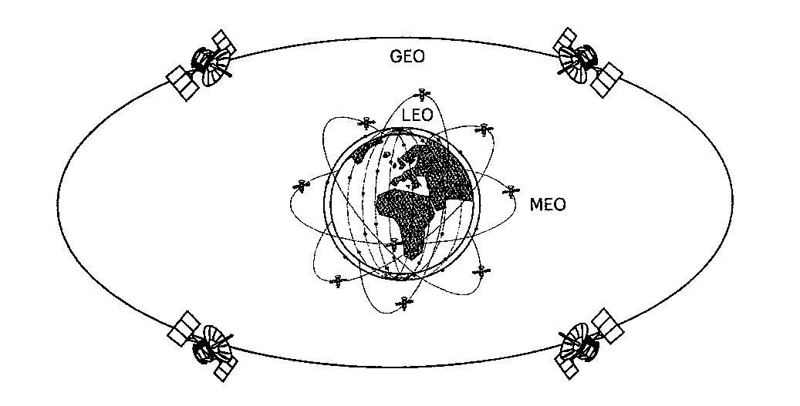

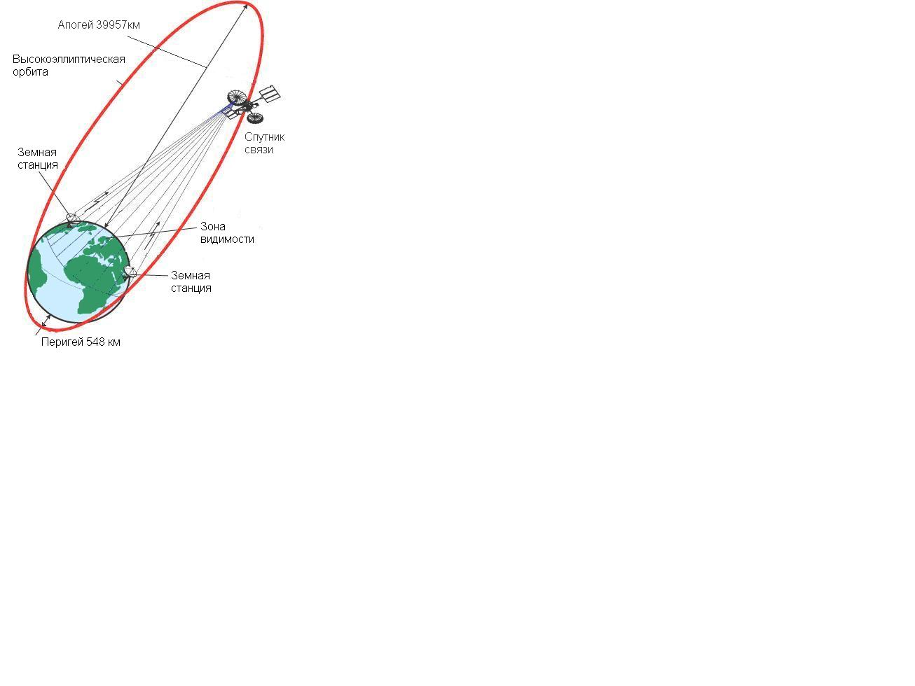

Figure 8.1 - Types of satellite orbits

a) circular low (LEO), mid-high (MEO), geostationary (GEO);

b) highly elliptical orbit

The most important parameter of the orbit is the revolution period T, defined as the time between two successive passage of the satellite through the same point in the orbit.

Low Earth Orbit (LEO) - with circular orbits with a height of 700 - 2,000 km. A satellite in low orbit is in the line of sight from a certain point on the earth's surface for only 8-12 minutes. Therefore, to ensure continuous communication, a large number of satellites (several dozens of satellites weighing up to 500 kg) are needed, which would interact using gateway stations or inter-satellite communications. To cover a large area of ​​the Earth with communications, such systems use orbits lying in different planes. Examples of systems: Globalstar, Iridium, Teledesic, "Signal", "Messenger".

Medium Earth Orbit (MEO) - with circular orbits 5,000 to 15,000 km high. With such orbits, the visibility time of one repeater satellite can be several hours, therefore, in the mid-orbit constellation, 9-12 satellites weighing up to 1,000 kg are sufficient. The propagation delay of the signal is about 130 ms and allows the use of such systems for radiotelephone communications. Examples of MEO systems are: Odyssey, ISO.

Geostationary (GEO - Geostationary Earth Orbit) - with circular equatorial orbits with a height of 35,875 km. In this case, the satellite’s period of revolution around the Earth is 24 hours. That is, the satellite is always above a certain point on the Earth. The advantage of such systems is the ability to cover the entire earth's surface with a small number of satellites (from three). The main disadvantages are the long duration of the propagation of the radio signal (delay of radio signals, echo), the large attenuation of the signal, it is impossible to discuss the polar regions. Examples of such systems are: Yamal (for digital television), as well as the geostationary grouping of the Inmarsat, Intelsat systems.

Highly Elliptical Orbit (HEO) - with elongated elliptical orbits with a perigee radius of about 500 kilometers and an apogee radius of about 40,000 km. An example of a satellite with NEO is the Molniya type satellites with a rotation period of 12 hours, an inclination of 63 °, an apogee height of 40 thousand km above the northern hemisphere, and 500 km of perigee. The motion of the satellite in the apogee region is slowed down, while the radio visibility is 6 ... 8 hours. The advantage of this type of satellite is the large size of the service area while covering high-latitude subscribers. The disadvantage of VEO is the need for tracking antennas for a slowly drifting satellite and their reorientation from a setting satellite to an ascending one, in addition, the Doppler effect is quite pronounced.

According to the covered territory, location and affiliation of the AP, the management structure of the CCC can be divided into:

- international, which includes stations of various countries; such systems can be global (covering almost the entire surface of the Earth) or regional.

An example of an international global system is Intersput-nick. International regional systems include such systems as Evtel-sat (Europe and North Africa), Arabsat (Arab countries) and others;

- national, AP of which are located within the same country. Including zone ones, the AP of which is located within one of the zones (regions) of the country, and departmental (company) systems, the AP of which belong to one department (organization) and transmit only business information and data in the interests of the department (Dedicated Satellite Communications Network Bank of Russia Banker).

Depending on the type of earth stations and the purpose of the system, according to the Radio Regulations, the following communication services are allocated:

- fixed-satellite service (FSS) is a radiocommunication service between earth stations at a given location when one or more satellites are used. These ES stations located at fixed points on the surface of the Earth are called FSS earth stations. The fixed-satellite service also includes feeder links (lines for supplying programs to the space station) for other space radiocommunication services, for example, for broadcasting satellite or satellite mobile services.

The main signals transmitted through the FSS communication lines are the signals of telephony, data, telegraphy, facsimile, television and sound programs.

Initially, they were deployed exclusively for the organization of highways and regional (zone-howl) communications.

The most significant commercial fixed line systems include Intelsat, Intersputnik, Eutelsat, Arabsat and AsiaSat;

- mobile satellite service (MSS) - between mobile satellite (or between mobile and fixed satellite) with the participation of one or several space stations (depending on the installation location of the mobile satellite distinguish between land, sea, air mobile satellite services) .

MSS subsystems were created mainly for networks having a radial or radial-node structure with large central and base stations, which provided work with mobile ground stations. Typically, such networks were intended to create departmental and corporate communication networks with remote and mobile objects, to organize communications in government agencies, in disaster areas and in emergency situations.

At present, the division of MSS systems by types of transmitted information on radiotelephone networks (Inmarsat-A, -B and -M, AMSC, MSAT, Optus, AceS) and data transmission systems (Inmarsat-C, Omnitracs, Euteltracs, Prodat) is partially preserved. .

Of all MSS systems, the most powerful orbital group belongs to the Inmarsat international system;

- broadcasting-satellite service (BSS) - a radio communication service in which the signals of space stations are intended for direct reception by the population. In this case, both individual and collective reception is considered direct; in the latter case, the broadcast program is delivered to individual subscribers using a particular terrestrial distribution system — cable or over-the-air — with a low power transmitter. Note that the term "broadcasting" combines television and sound broadcasting. The broadcasting-satellite service defined in this way does not include all types of satellite-based broadcasting systems, but only those that are designed to be received at relatively simple and inexpensive receiving installations with a quality sufficient for the subscriber, but often lower than required from the main lines for supplying programs to terrestrial broadcasting stations.

Currently, all broadcasting systems are built on the basis of satellites, in a geostationary orbit.

Separately considered satellite navigation systems (NSS), used to determine the coordinates of moving objects and their navigation.

Table 8.2 shows the international names of the frequency ranges used in satellite communications and broadcasting systems and the services in which these frequencies are applied.

 Table 8.2 - Frequency ranges for satellite communications

|  |  |  |
| --- | --- | --- |
| Range name | Frequency, GHz | Service  Radio communications |
| L | 1,452-1,550 и 1,610-1,710 | MSS, NSS |
| S | 1,93 - 2,70 | Pss |
| C | 3,40 -5,25 и 5,725 - 7,075 | FSS, RCC |
| X | 7,25 - 8,40 | Scientific research |
| Ku | 10,70 - 12,75 и 12,75 - 14,80 | FSS, RCC |
| Ka | 15,40 - 26,50 и 27,00 - 30,20 | FSS, PSS (multipath systems) |
| ENF | 40/50 | PSS (perspective) |

The Earth’s radiation belts are marked with a darkened color, the orbits are not located here, since the belts adversely affect the performance of the solar satellite satellites.

Figure 8.3 explains the basic quantities that determine the relative position of the ES and the geostationary satellite.

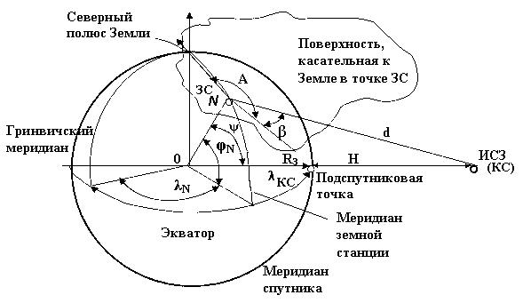

Figure 8.3 - Determination of azimuth A and elevation angle β for a geostationary satellite

The intersection point of the radius vector drawn to the satellite’s location from the center of the Earth to the Earth’s surface is called the sub-satellite point.

At any other point N of the earth’s surface, the position of the axis of the antenna beam of the ZS antenna differs from the zenith and is characterized by two angular magnitudes: azimuth $А$ and elevation angle $β$. Elevation angle (elevation angle) β-angle between the direction to the satellite and the projection of this direction onto the plane tangent to the Earth’s surface at the point of location of the AP.

Knowing the coordinates of the satellite in a geocentric system, we can calculate the azimuth A and elevation $β$ for any point on the Earth’s surface:





where λКС  is the satellite longitude;

       λN - longitude of the earth station;

       К = Н + RЗ = 42,170 km is the radius of the orbit relative to the center of the Earth;

       RЗ = 6.37 thousand km - the radius of the Earth;

       H = 36 thousand km - the height of the orbit;

*α* = А+1800 for earth stations located in the Northern Hemisphere and satellites located west of the earth station;

*α* = 1800-- A for earth stations located in the Northern Hemisphere and satellites east of the earth station;

*α* = 3600-- A for earth stations located in the Southern Hemisphere and satellites located west of the earth station;

*α* = A for earth stations located in the Southern Hemisphere and satellites east of the earth station;

ϕN - latitude of the earth station.

By a certain value of the elevation angle, you can find the boundary of the *satellite visibility zone.*

A *satellite’s visibility zone* is understood to mean the Earth’s surface, from which the satellite can be seen at an elevation angle greater than some acceptable value. In reality, in order to avoid shadowing of the satellite by earth objects, elevations, as well as an increase in noise due to the reception of noise radiation from the *β* >5° or *β* >10°.

Using the above notation, the distance from the AP to the CS is calculated by the formula:

 (8.1)

In this case, d will reach a maximum value of dмакс  = 42250 km at φЗС =75◦ north or south latitude.

**Lecture 8. Main characteristics, space structure stations.**

The purpose of the lecture: To study the composition of space and earth stations and their main characteristics.

The space platform is the basic part of the spacecraft, on which the payload (airborne relay complex) is located, the power subsystem and the airborne control system that ensures the normal functioning of the spacecraft during orbital flight for the entire period of its active existence.

*The onboard control* complex consists of several subsystems. One of them provides the correct orientation and stabilization of the satellite position in space. It is known that the effective mode of operation of solar panels and radio lines depends on the orientation of the solar panel (they should always be oriented to the Sun) and antenna systems (always directed to the Earth).

Also, the onboard control system contains a telemetry system. The telemetry and telecontrol system is designed to monitor and control the operating modes of all CS systems and transmit this information to the GS. The information transfer speed on command and telemetric radio links usually ranges from several hundred bits to 100 kbit / s.

Important functions are performed by the *thermoregulation subsystem*, which ensures the maintenance of the thermal regime of the payload (satellite equipment) within specified limits. The usual operating temperature range of on-board equipment is from -200 till +500С.

The main characteristics of the platform are its mass and dimensions, the power of the onboard power supply system and the period of active existence.

There are propulsion systems on board any satellite that stabilize its position in orbit by commands from the operator from the Earth. The life of a satellite is generally limited by the life of the batteries and the amount of fuel for correction engines that it can take on board.

Depending on the type of satellite, its life span is from 7 to 12 ... 15 years. After this period, on the remnants of fuel at the command of the Earth, the satellite is dumped into the ocean.

A complex of relay equipment that a spacecraft puts into orbit is called a payload or an airborne relay.

The structure of the airborne relay complex (BRTC) is determined by its purpose, or the extent of coverage of the territories, the method of processing information on board the CS, the number of relay channels, the speed of information exchange, as well as selected technical solutions and technologies used.

The type of antennas used at the CS depends on the satellite’s orbit and its on-value. And yet, parabolic antennas are most often used, since they are broadband, have a high GA gain, and allow you to form the main lobe of the radiation pattern of different widths.

The diameter of the antenna determines the size and cost of the CS, therefore, is one of the main characteristics of the CS. Typical CS antenna diameters are from 0.30 m to 5 m. The gain is calculated by the formula (6.5), and the antenna radiation pattern width is determined by the formula:

θ0,5=600DА/λ, degrees

where DА  is the diameter of the antenna, m;

λ is the working wavelength, m

Multifunctional geostationary satellites mainly use 4 types of antennas:

- global (beam width 17 ° × 17 °);

- semi-global (8.7 ° × 8.7 °);

- zonal (5 ° × 5 °; 5 ° 11 °; 3.5 ° × 7 °);

- narrowly directed (1 ... 2 °).

The width of the main beam of the CS antenna determines the service area (coverage) of the CS.

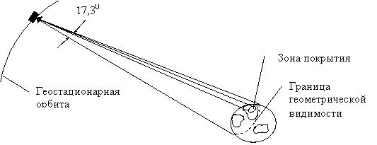

Figure 9.2 - Visibility and service area of ​​a geostationary satellite

The part of the visibility zone, where the specified communication quality is ensured at certain parameters of the AP, is called *the coverage area (service area),* within which the mandatory EMC condition with other radio facilities must be met, and the ability to receive signals from the earth station at the satellite input is guaranteed, having a certain equivalent isotropically radiated power.

The frequency ranges for reception and transmission are usually designated in accordance with the used frequency range. For example, the C range is 6/4 GHz, Ku is 14/11 GHz, with the first digit indicating the frequency of the signal on the way from the AP to the SC (uplink), and the second on the way from the SC to the SC (downlink) .

The quality factor of the station for GA / T reception, measured in dB / K, is determined by the ratio of the antenna gain to the total noise temperature of the on-board receiver, determined by the following formula:



GA - receive antenna gain

TШ ПРМ - effective noise temperature of the receiving path.

Usually this value for KS has values: from -12 to +3 dB / K

An important characteristic of an airborne transponder is the number of trunks (the English term “transponder” is often used instead of the term “trunk”).

 A repeater trunk is a transceiver path in which radio signals pass in a certain common frequency band.

The number of trunks on various satellites varies between 6 ... 48.

The use of multi-barrel CS requires the use of frequency plans for satellite systems. In the high-frequency ranges (C, Ku, Ka), the difference between the frequency of reception and transmission of one barrel is at least 2 GHz, and the spacing between the frequencies of the trunks is 50 MHz.

The trunk bandwidth is also different (36; 40; 72; 77; 112; 120 MHz, etc.).

Bandwidth - the number of channels that can be organized through the BR, or the maximum signal transmission speed depends on the number of trunks, the signal modulation method.

The energy potential of the transmitting station is estimated by the effective isotropically radiated power (EIRP), which is determined by the product of the transmitter power, the efficiency of the waveguide path and the antenna gain.

EIRP $=$ РПРД⋅GА⋅ηАВТ, Вт,

where: РПРД, - maximum transmitter power, W;

ηАВТ - efficiency of the antenna-waveguide path;

         GА - antenna gain for transmission.

EIIM CS from 23 to 45 dBW, but on the satellite of direct television broadcasting reaches 52 ... 58 dBW. 20-35 dBW for spacecraft in medium orbits and 5-25 dBW for spacecraft in low orbits.

The power flux density at the surface of the earth created by the CS is calculated by the following formula:

W = EIRP −LР+20*lg f +21,5 , дБВт/м²

where f is the frequency, GHz;

       EIRP - effective isotropically radiated power, dBW;

       LР - attenuation of the signal along the propagation path, dB.

The service life of the COP is an important feature, as mentioned above.

Relay Types

- transparent;

- regenerative;

- combined.

Transparent repeaters (bent pipe) provide reception and conversion of input signals without processing them on board. Two types of frequency conversion can be used:

- a single system that converts the frequency of the reception band directly into the frequency of the transmission band (direct conversion);

- a double conversion system in which the frequencies of the received signals are first converted to intermediate frequencies for partial amplification, and then converted again to the frequencies of the transmitted signals (conversion at an intermediate frequency). The block diagram of the BR is shown in Figure 9.3.

ав

Г1

ав

Г2

МШУ

УПЧ

fПРМ

fПЧ

fПЧ

fПРД

УМ

Figure 9.3 - Block diagram of the BR with signal conversion

at intermediate frequency

Regenerative BRs are defined as repeaters with On Board Processing. Their work is based on the reception of signals at a single frequency, their demodulation and re-modulation on a new carrier. The use of such repeaters allows you to simultaneously serve a large number of terminals, providing greater flexibility in channeling and the operational connection of terminals using a variety of protocols.

Combined repeaters can process

only certain signals (some part of all channels), for example, corresponding to a given carrier frequency.

Most modern airborne repeaters incorporate a switching stage, which can significantly simplify subscriber equipment on the ground.

Figure 9.4 shows a block diagram of a multi-barrel airborne repeater.

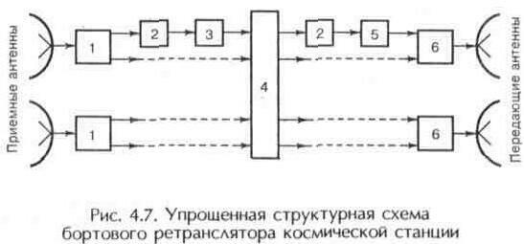

1 input device (low-noise amplifier); 2 frequency converter; 3 amplifier; 4 switching device; 5 step-up frequency converter; 6 power amplifier.

Figure 9.4 - Simplified block diagram of an onboard repeater

The main functional part of the transmission path is the transmitter power amplifier. In airborne complexes, various types of such devices are used. In communication systems at geostationary CS, the main type of amplifiers for transmitters is amplifiers based on a traveling wave lamp (TWT), their efficiency exceeds 40%.

Semiconductor amplifiers with power up to 60 W for the L-frequency range, up to 20 W for the C-band and 5-10 W for the Ku-band are usually used in systems with spacecraft in medium-high and low orbits.

Unlike amplifiers with TWT, this equipment operates at a lower supply voltage, more compact and reliable.

Currently, low-noise amplifiers (LNAs) based on field-effect transistors are most often used in the input stages of airborne receivers. The noise figure of such a receiver is less than 3 dB in the frequency range 1.5-4 GHz and not more than 4.5 dB for the range 11-14 GHz.

Subsystem broadband receivers BR. This subsystem provides the first stage of signal amplification and the transfer from the reception frequency band to the transmission frequency band in the case of a system with one frequency conversion.

 In a dual conversion system, a broadband receiver provides signal amplification and conversion of the receiving frequency to an intermediate frequency. Typically, the receiver gain is approximately 50-60 dB.

 Typical structural schemes of airborne relay systems are described in [1].

**Lecture 9. Ground segment. The structural diagram of the earth station. VSAT systems**

 The purpose of the lecture: to get acquainted with the composition and purpose of the ground segment, schemes of earth stations, the principles of construction of VSAT systems

Figure 10.1 shows a functional block diagram of a satellite communications system, the three components of its segment are highlighted. The ground segment includes gateway earth stations, monitoring and control stations of the communication network.

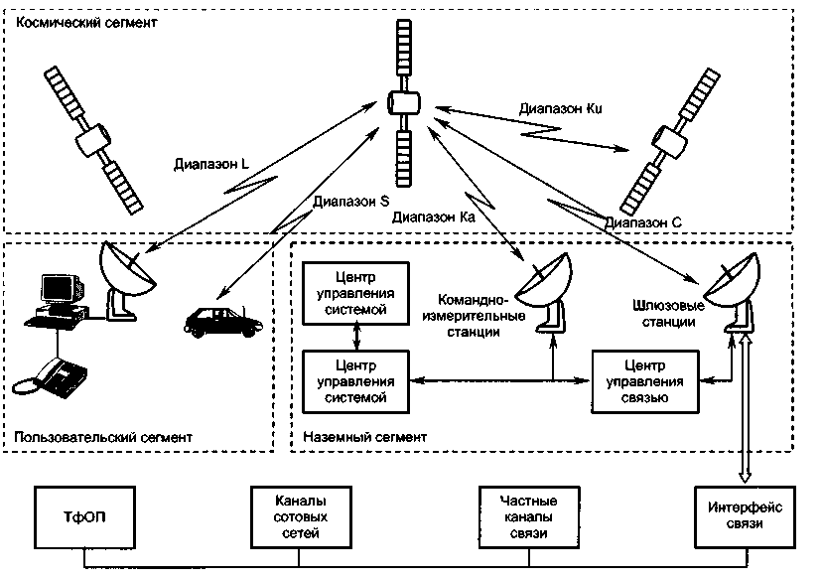

Figure 10.1 - Composition of a satellite communications system

An earth station (AP) is the terminal transmitting and receiving link of a communication link through a satellite. The general construction of the AP is shown in Figure 10.2. The station consists of the following main subsystems:

-antenna system;

-low noise receiver amplifiers;

-transmitter power amplifiers;

- communication equipment (frequency converters and modems);

-sealing / decompression equipment;

- equipment for connection to a land communication network;

-auxiliary equipment (control and monitoring equipment, measuring equipment, service channel equipment);

-power supply equipment (network power supply with redundancy and uninterruptible power supplies);

-general-purpose infrastructure (all premises, buildings and structures).

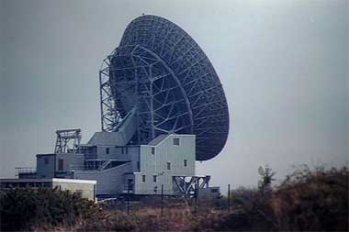

Figure 10.2 - Gateway earth station

Most gateway stations are transceivers.

Antenna system AP. The diameter of the antenna can be from about 33 m to 3 m or less. Earth station antennas are used simultaneously for reception and transmission and should have the following characteristics:

- high gain for transmission and reception, for which the reflectors must be large compared to the wavelength and have high efficiency;

- low level of generated interference (for transmission) and low sensitivity to interference (for reception), as a result of which the radiation pattern of the antenna should have a low level outside the main beam (small side lobes);

- high polarization purity of radiation;

- low sensitivity of the receiving path to thermal noise due to ground radiation and various losses.

The antenna beam should maintain its direction to the satellite under any external conditions and regardless of the satellite’s residual movement: (in the case of an INTELSAT system standard A antenna with a diameter of 30 m, the angular accuracy should be about 0.015 °). Therefore, even in systems operating with geostationary CS, an automatic tracking device is required that controls the drive mechanisms of the antenna.

Low noise amplifiers. In order to receive a very weak signal from a satellite, the earth station antenna must be connected to a receiver with very low intrinsic thermal noise. Thus, a low-noise amplifier is always a preliminary amplifier of the microwave receiving paths of a satellite communication station. It should be placed as close as possible to the antenna feeder diplexer in order to avoid additional noise due to losses in the waveguide. A low-noise amplifier is usually broadband: one amplifier simultaneously amplifies all carriers coming from the receive port of the antenna diplexer. Typically, a backup amplifier is also installed (1 + 1 redundancy). Recent advances in field effect transistors based on gallium arsenide (GaAs) have led to the creation of simpler and cheaper transistor amplifiers. In modern LNAs operating in the C and Ku bands (bandwidth from 500 MHz to 1 GHz), the equivalent noise temperature is 50-150 K, and the gain is 30-40 dB.

The most important element of the transmitter is the amplifier. The order of magnitude of the required power at the transmitter output is 1 W or less for a telephone channel and 1 kW for a television carrier. At the output of the power amplifier (if necessary, amplifications up to 0.5-3 kW) are used either klystrons or traveling wave tubes (TWT). The main advantage of klystrons is high stability and low noise level, while TWT provides a large (compared with them) bandwidth. In amplifiers with a power of 0.5-1 kW, TWT is usually used, and in more powerful (1-3 kW) klystrons.

The composition of the terminal equipment depends on the purpose of the earth station and the type of information transmitted. For data networks, these can be packet collectors / parsers, packet switches, etc. In telephone communication systems, this includes modems, encoders and decoders, switches and automatic telephone exchanges.

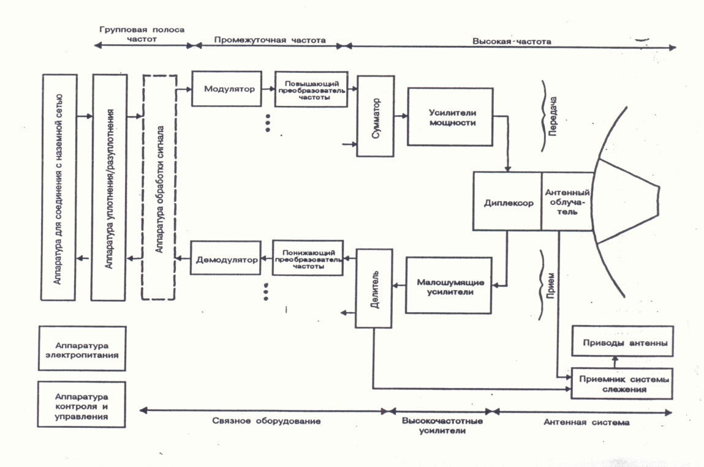

Figure 10.3 - Block diagram of a typical earth station

Trunk equipment is designed to interface earth stations with terrestrial communication lines and user equipment.

Thanks to progress in the field of microelectronics and radio engineering, small-sized and relatively inexpensive earth stations, called the VSAT (Very Small Aperture Terminal), have appeared on the world market. Basically, VSAT terminals have mirrored parabolic antennas with a diameter of up to 2.4m.

Currently, VSAT networks are used to exchange information between earth stations (AP), to connect remote subscribers with data networks, as well as in information collection and distribution systems. The use of equipment such as VSAT is especially effective in remote areas where the organization of other types of communication is difficult. The structure of the VSAT satellite network is shown in Figure 10.3.

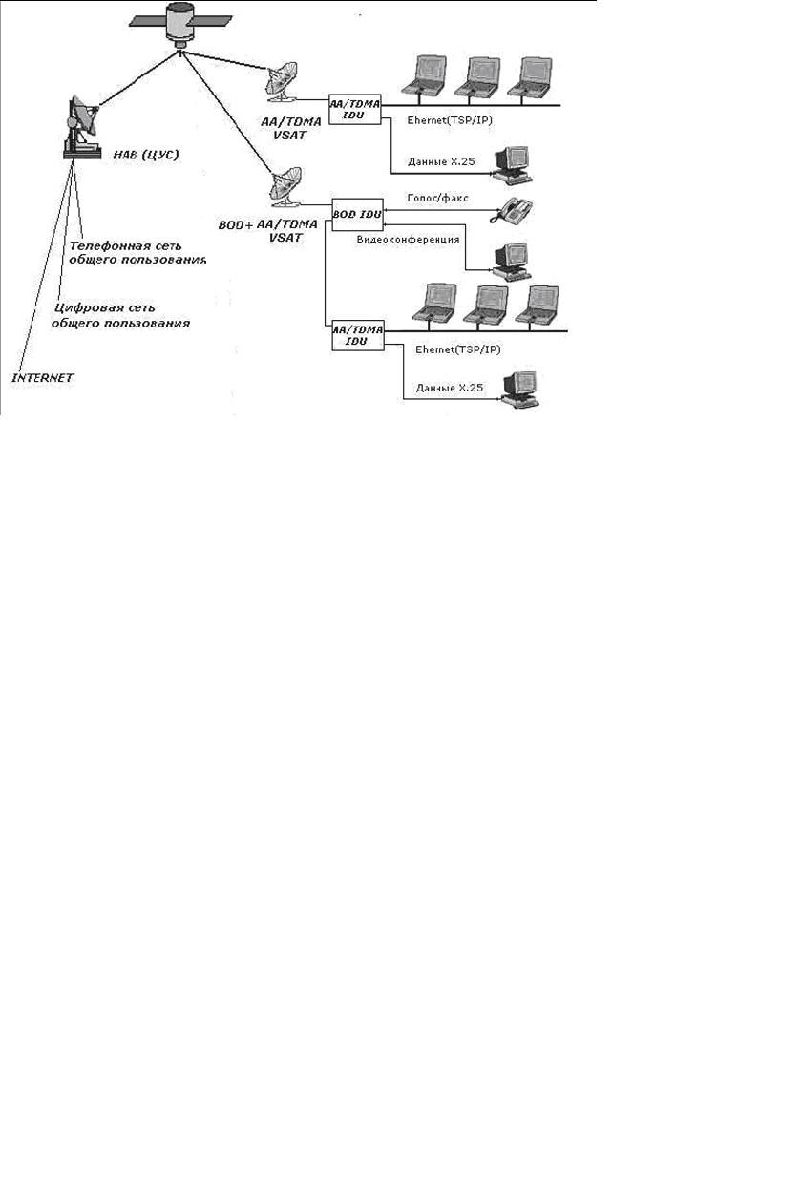

Figure 10.2 - The structure of the satellite network VSAT

One-way communication systems allow transmitting from a central point to many remote points where the antennas are configured only for reception (an example is the Intelnet network based on VSAT terminals for transmitting data for broadcasting purposes). In turn, interactive communication networks are used to transmit voice and data. One-way video transmission can be easily added to the interactive network. To reduce the user’s costs for paying for the satellite transponder resource, the construction of VSAT networks is based on the separation of several satellite channels between many users. VSAT networks are based on the most modern satellite network building technologies based on different principles of satellite transponder resource sharing, and have different topologies. The VSAT network supports data and voice messaging modes PAMA (multiple access with constant channel provisioning) and DAMA (multiple access with channel provisioning on demand). Table 10.1 presents the characteristics of foreign VSAT systems.

Table 10.1 - Foreign systems of Star-type VSAT networks



Currently, VSAT networks with Mech topology and interactive satellite access networks are widely used.

A subscriber's VSAT terminal typically includes an antenna feeder device, an external external RF unit, and an indoor unit (modem). The external unit is a small transceiver or receiver. The indoor unit allows the satellite channel to interface with the user's terminal equipment (computer, LAN server, telephone, PBX fax, etc.).

The popularity of VSAT in comparison with other types of communication when creating corporate networks is explained by the following considerations: for networks with a large number of terminals and with significant distances between subscribers, operating costs are significantly lower than when using terrestrial networks:

- Complete independence from terrestrial network operators.

-Fast deployment and reconfiguration of the network.

-High reliability reaching 99.9%.

-A wide range of services (data, voice, video).

Currently, the cost of one minute of conversation over a satellite communication channel is from 3 to 15 cents, and modern VSAT terminals cost from 3 to 5 thousand dollars in the basic configuration and provide transfer speeds from 16 kbit / s to 2 or more Mbit /from.

Installing and connecting a VSAT-class terminal to the network takes several hours.

**Lecture 10. Energy calculation of satellite communication line.**

The purpose of the lecture: To study the methodology for calculating the satellite communication line.

The purpose of the calculation: to determine the values ​​of the transmitter power of the earth transmitting station RPRDZS and the transmitter power of the on-board repeater RPRDKS, at which the satellite channel reliably operates in the conditions of interference and does not contain excessive energy reserves.

Also, during the calculation, it is necessary to determine the power of the transmitted signal to ensure the necessary signal-to-noise (C / N) ratio at the receiver input.

A satellite communication line is conditionally divided into two sections: an uplink from an AP to an SC and a downlink from an AP to an AP.

Before starting the calculation, we determine the frequency ranges, multiple access methods and the use of the frequency band, the mode of operation of the repeater, the types and parameters of modulation used, service areas and other source data.

Consider one section of a satellite line consisting of a transmitting and receiving device, an antenna path and a propagation path, as shown in Figure 11.1.

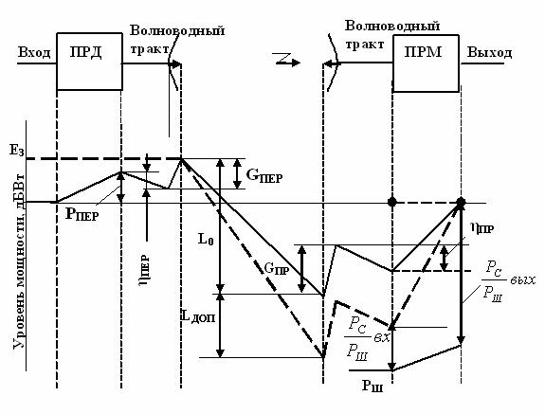

Figure 11.1 - Block diagram and level diagram of one section of a satellite link

When matching the wave impedances of the antenna, path elements and the receiver, the signal power at the receiver input



where d is the distance between the transmitting and receiving antennas, m;

            λ is the wavelength, m;

       RPRD - transmitter power, W;

       GPRD, GPRM - gain of the transmitting and receiving antennas, dB;

       PRD, PFP - transmission coefficient of waveguide paths;

       LDOP - additional signal attenuation.

Signal energy attenuation in free space - decrease in power flux density when moving away from the emitter



where λ is the wavelength;

d is the slant range (distance between the transmitting and receiving antennas).

The distance between the transmitting and receiving antennas for satellite systems operating with geostationary satellites is determined by the formula 8.1. For systems. Working with spacecraft in non-geostationary orbit, the distance will change when the satellite moves and there are various calculation methods [4].

Having expressed the transmitter power from equation (11.1), we obtain a formula that allows you to determine the necessary transmitter power from a given value of the signal power at the receiver input.

The signal power at the input of the receiver, which must be obtained for high-quality signal reception, is expressed in terms of the signal-to-noise ratio at the input of the receiver and the total noise power. Then the formula for calculating the power of the transmitter AP takes the form:



where is the noise power of the receiving system, 0K;

k is the Boltzmann constant;

TΣ is the equivalent noise temperature of the entire receiving system, taking into account internal and external noise, 0K;

Δf is the equivalent noise band of the receiver, Hz;

a = 5 - safety factor for the line up.

For the "down" line, the equation for calculating the power of the transmitter KS:



Additional signal attenuation takes into account attenuation in atmospheric gases, precipitation, and other causes of signal attenuation.

Another important issue considered in the design of satellite communications systems is the electromagnetic compatibility of satellite and terrestrial communications systems.

Mutual interference arising from the sharing of common sections of frequency bands can be divided into internal and external. In RRL, intra-system interference is caused by interfering signals from neighboring trunks, signals received from the opposite direction due to the back lobes of the antenna radiation pattern, signals from stations spaced three intervals apart, etc. Sources of external interference are neighboring RRL, CCC, SSB, signals radar stations using common frequency bands.

To reduce interference in terrestrial systems from satellite emissions, the maximum signal power flux density developed at the Earth's surface is limited to W.

W (dBW / m²) must satisfy the following conditions:

-W = W0 at ε ≤ 5 °,

-W = W0 + 0.5 (ε - 5 °) at 5 ° <ε ≤25 °,

-W = W0 + 10 at 25 ° <ε ≤90 °, where ε is the elevation angle;

Frequency dependent:

-W0 = - 152 dBW / m² for 3.4-7.75 GHz;

-W0 = - 150 dBW / m² for 10.7-11.7 GHz;

-W0 = - 148 dBW / m² for 12.2-12.75 GHz;

-W0 = - 115 dBW / m² for 17.7-19.7 GHz and 31-40.5 GHz.

W is determined within the conditional control frequency band: 1 MHz for the ranges 17.7-19.7; 31-40.5 GHz and 4 kHz for the rest (lower frequency).

**Lecture number 11. Electromagnetic compatibility.**

EMC (electromagnetic compatibility) of geostationary-satellite communications networks sharing the same frequency bands.

The administration intending to create an MSS should not earlier than 6 years and no later than 2 years before the planned launch date of the system send to the Radiocommunication Bureau for publication information about the MSS being created. The administration of the existing MTS sends its comments to the notifying administration if it considers that its existing services may be subject to unacceptable interference.

Both parties must find a mutually acceptable solution in the coordination process. The need for coordination is calculated by the method described below in Appendix 29, Volume 2 of the ITU Radio Regulations, 1990.

The scheme for evaluating the interfering influence when calculating the need for coordination is shown in Figure 11.2. We consider systems working with geostationary satellites.

**КС1**

**КС2**

α1

α2

θ1

θ2

d1

d2

d3

d4

θg

Действ. система 1

Проектируемая система 2

**ЗС1**

**ЗС2**

Figure 11.2 - Scheme for assessing the interfering effect of CCC

The following notation is used in the figure: d1 ... d4 - distance between stations; θ1, θ2 - topocentric angles in the case of CS; α1, α2- exocentric angles in CS; θg is the geocentric angular separation between the satellites.

The influence of the designed system on the existing one is estimated by the increment of the noise temperature of the existing system. This increment consists of two terms ΔTЗС and ΔTКС.

It is more convenient to use for calculating formulas in which values ​​are expressed in decibels.

ΔTZS = SBR2 + GBR2 (α2) + GZS1 (θ1) -k-Lp ↓, dBK,

ΔTKS = SЗC2 + GКС1 (α1) + GЗС2 (θ2) -k-Lp ↑, dBK.

where SBR2, SZC2 are the spectral power densities of BR2 and ZS2 in technical specifications, as a rule, are indicated in dBW / Hz;

      LР ↑ - attenuation of interfering signals along the propagation path in the upward section, dB;

GЗС2 (θ2), GЗС1 (θ1) —gain antennas antenna gain of the designed and existing systems, depending on the topocentric angles θ, dB;

     GBR1 (α1), GBR2 (α2) - gain antennas of the CS of the existing and designed systems, depending on exocentric angles α, dB;

k– Boltzmann constant (-228.6), dB.

Attenuation in free space is determined by the following formula:

Lp = Lo = 20 (log f + log d) + 32.45 [dB],

where f is the frequency, MHz;

      d - distance, km.

The distance is calculated by the formula 8.1.

Reference formulas for calculating the gain of AP antennas depending on the angle, taking into account the side lobes of the antenna pattern:

For DA / λ ≥ 100

G (θ) = Gmax - 2.5 * 10-3 (θ DA / λ), dB

for 0 <θ <θm;

G (θ) = G1, dB for θm <θ <θr;

G (θ) = 32 - 25 logθ, dB, for θr <θ <480;

G (θ) = -10, dB, at 480 <θ <1800,

where DA is the diameter of the antenna, m;

      θ is the angle (in degrees), measured from the axis of the antenna, equal to θt.

      G1 = 2 + 15lg (DA / λ) - antenna gain in the direction of the maximum of the first lobe, dB;

    θm = (20 λ / DA) Gmax-G1 - width of the first lobe, degrees.

θr = 15.85 (DA / λ) -0.5, degrees.

For DA / λ <100

G (θ) = Gmax - 2.5 * 10-3 (θ DA / λСР), dB at 0 <θ <θm;

G (θ) = G1, dB for θm θ <100λ / DA;

G (θ) = 52 - 10 log DA / λav – 25lgθ, dB at 100λ / DA θ <480;

G (θ) = -10, dB at 480 θ <1800

The topocentric angle at earth stations is determined by the following formula:



θ2 is defined in a similar way.

Then we translate the increment of noise temperature into kelvin using the relations:

ΔTЗС = 10 ΔTзс (dB) / 10, 0K;

ΔTKS = 10 ΔTx (dB) / 10, 0K.

The total increment of the noise temperature of the entire system is calculated.

ΔT∑ = γΔTKS / + ΔTЗС / Y, 0К

where γ is the transmission coefficient of the satellite communication line;

Y is the attenuation coefficient of the interfering signal due to polarization mismatch (1 for coinciding polarizations, 4 for circular polarizations with the opposite direction of rotation, and 1.4 in other cases).

It is believed that the effect is not significant and coordination between systems is not required if the relative increment of the noise temperature of the existing system does not exceed 6%. This is determined by the inequality:

∆Т∑ / TСЛС ≤ 6%,

where TSLS is the noise temperature of the existing satellite system.

In practice, mutual interference is also calculated, which depends on a number of factors, including transmitter power, type of modulation, antenna gain in the direction of interfering signals, acceptable interference levels at the input of receivers, radio wave propagation mechanisms, radio-climatic conditions, distance between stations and the profile of the surrounding area .

Coordination zones are being constructed for satellite stations, and if the RRL stations are outside these zones, mutual interference calculations can be omitted.

To reduce mutual interference, the relative position of the satellites, the parameters of the signals and antennas, the power of the transmitters can be changed, and interference cancellers or special carrier dispersion signals can be used.

Another method of reducing interference is the use of sector antennas. When you select the appropriate frequency allocation rule between sectors of the wireless access network (so that the frequencies do not coincide in neighboring sectors), you can always plan the operation of the AP so that its operating rating does not coincide with the nominal operating frequency of the sector. Additional spatial isolation can be up to 20-25 dB in this case.

The traditional method of reducing interference is to introduce frequency detuning between the radio signals of the affected and interfering RES.

**12 Lecture EMC geostationary-satellite communications networks sharing the same frequency bands**

Purpose of the lecture: EMC of geostationary-satellite communications networks sharing the same frequency bands

The administration intending to create an MSS should not earlier than 6 years and no later than 2 years before the planned launch date of the system send to the Radiocommunication Bureau for publication information about the MSS being created. The administration of the existing MSS sends its comments to the notifying administration if it considers that its existing services may be subject to unacceptable interference. Both parties must find a mutually acceptable solution in the coordination process. The need for coordination is calculated by the method described below in Appendix 29, Volume 2 of the ITU Radio Regulations, 1990

### КС1

### КС2

α1

α2

θ1

θ2

d1

d2

d3

d4

θg

Действ. система 1

Проектируемая система 2

### ЗС1

### ЗС2

Figure 6.2 - Assessment scheme for the interfering effect of the designed CCC2 on the current CCC1

The calculation method is based on the notion that when exposed to interfering signals, the effective noise temperature of the system undergoing interference increases.

According to this method, the apparent relative increase in the noise temperature of the existing ∆Т∑ / Т∑ line due to the influence of interfering signals created by the designed system is calculated and compared with a threshold value of 6%.

Let us evaluate the interfering influence of the designed system 2 (see Figure 5.2) on the current system 1, therefore, we will be interested in receiving paths in system 1, and transmitting paths in system 2. The following notation is used in the diagram:

d1 ... d4 - distances between stations;

θ1, θ2 are topocentric angles;

α1, α2- exocentric angles;

g is the geocentric angular separation between the satellites.

γ is a coefficient numerically equal to the transmission coefficient of the path from the output of the receiving antenna KS1 to the output of the receiving antenna ZS1 (usually less than 1);

Т∑ - effective noise temperature of the receiving path ЗС2 (without taking into account the interfering effect).

      So, the compatibility criterion

                          ∆T∑ / T∑ ≤ 0.06. (6.5)

Formulas used for calculations

ΔT∑ = γΔT ↑ / Y + ΔT ↓ / Y (6.6)

where ΔT ↑, ΔT ↓ is the increment of the noise temperature in the section up and down;

Y is the attenuation coefficient of the interfering signal due to polarization mismatch (1 for coinciding polarizations, 4 for circular polarizations with the opposite direction of rotation, and 1.4 in other cases).

ZS of the designed system, using the same frequency band as the ZS of the current system, will cause increments in the noise temperature of the current CS ΔT ↑.

ΔТ ↑ = SЗС2GЗС2 (θ2) GББ1 (α1) / (Lp ↑), K

where SЗС2 [W / Hz], is the spectral power density of ЗС2;

LР ↑ - attenuation of interfering signals along the propagation path upward;

GЗС2 (θ2) is the antenna gain of the AP of the designed system, depending on the topocentric angle θ2;

GBR1 (α1) - antenna gain of the CS of the existing system, depending on the exocentric angle α1;

k = 1.38 * 10-23 - Boltzmann constant W / (HzK).

The CS of the designed system using the same frequency band as the CS of the current system will cause increments in the noise temperature of the active CS ΔT ↓.

ΔT ↓ = SBR2GBR2 (α2) GZC1 (θ1) / (kLp ↓), K

SBS2– power spectral density of BR2, W / Hz;

LР ↓ - attenuation of interfering signals along the propagation path in the downward section;

GЗС2 (θ2) is the antenna gain of the AP of the designed system, depending on the topocentric angle θ2;

GBR1 (α1) - antenna gain of the CS of the existing system, depending on the exocentric angle α1;

k = 1.38 * 10-23 - Boltzmann constant W / (HzK).

       It is more convenient to use for calculating formulas in which values ​​are expressed in decibels.

ΔT ↓ = SBR2 + GBR2 (α2) + GZC1 (θ1) -k-Lp ↓, dBK,

ΔT ↑ = SЗC2 + GКС1 (α1) + GЗС2 (θ2) -k-Lp ↑, dBK.

SBR2, SZC2 - power spectral densities of BR2 and ZS2 in technical specifications are usually indicated in dBW / Hz;

k– Boltzmann constant (-228.6), dB.

Attenuation in free space is determined by the following formula:

Lp = Lo = 20 (log f + log d) + 32.45 [dB]

where f is the frequency, MHz; d - distance, km.

The distance is calculated as in the energy calculation.

GC antenna gain factors are determined by the actual measured characteristic or if such information is not available The Radio Regulations recommends the use of the following reference radiation patterns

 For DA / λCP ≥ 100

G (θ) = Gmax - 2.5 * 10-3 (θ DA / λСР), dB at 0 <θ <θm;

G (θ) = G1, dB for θm <θ <θr;

G (θ) = 32 - 25 logθ, dB, for θr <θ <480;

G (θ) = -10, dB, at 480 <θ <1800

where DA is the diameter of the antenna, m; θ is the angle (in degrees), measured from the axis of the antenna, equal to θt;

G1 = 2 + 15lg (DA / λ) - antenna gain in the direction of the maximum of the first lobe, dB;

Θm = (20 λ / DA) Gmax-G1 - width of the first lobe, degrees;

Θr = 15.85DA / λ) -0.5, degrees.

 For DA / λav <100

G (θ) = Gmax - 2.5 * 10-3 (θ DA / λСР), dB at 0 <θ <θm;

G (θ) = G1, dB for θm θ <100λ / DA;

G (θ) = 52 - 10 log DA / λav – 25lgθ, dB at 100λ / DA θ <480;

G (θ) = -10, dB at 480 θ <1800

The topocentric angle at earth stations is determined by the following formulas:



θg = │βKS1 − βKS2│ is the geocentric angle.

θ2 is defined in a similar way.

If CSs have global coverage antennas, then the antenna gain of the onboard repeater GBR (α) will not depend on the exocentric angle α, GBR (α) = GBRMAX.

Under other conditions, the exocentric angle is determined from the cosine theorem, determining the distance between earth stations

d ² ss1 ss2 = d1² + d2² - 2 d1 × d2 × cosα1, (6.7)

x1 = RЗ × cos φ1 × cos β1,

y1 = RЗ × cos φ1 × sin β1,

      z1 = RЗ × sin φ1,

where the radius of the Earth RЗ = 6370 km; φ1, φ2- latitude of the GC;

β1, β2 - longitudes of the GL.

        We similarly define x2, y2, z2.

d ²зс1зс2 = (x2 - x1) ² + (y2 - y1) ² + (z2 - z1) ². (6.8)

Calculating d ²зс1зс2 and solving equation 6.7 with respect to α1 we get:

Similar calculations are performed for α2 using the distances d3, d4. Thus, to determine exocentric angles, it is first necessary to determine the distance between them from the coordinates of the CS, and then use the cosine theorem.

 The antenna gain of the COP is determined by the formulas (in dB):

 G (α) = Gm − 12 (α / αo) at 0.5αo≤α <1.3αo,

 G (α) = Gm − 20 for 1.3αo≤α <3.15αo,

 G (α) = Gm − 7−25 logα / αo at 3.15αo≤α <α1,

 G (α) = - 10 for α1≤α

where αo is the beam width at half power;

Gm = 44.4−20lgαo - maximum gain.

If the values ​​ΔT ↑ and ΔT ↓ were calculated in decibels, then before substituting into formula (6.6), it is necessary to express them in Kelvin.

Substituting ΔT∑ into inequality (6.5) to determine whether coordination is required.

**Lecture №13. Communication satellite of the Republic Kazakhstan «KazSat».**

KazSat is the first spacecraft for Kazakhstan, with the launch and operation of which the implementation of space programs of the Republic began.

Pre-launch preparation of the components of the launch vehicle, upper stage and spacecraft at the cosmodrome was carried out by specialists of the state space research and production center named after M. V. Khrunichev (hereinafter-GKNPTs them. M. V. khrunicheva) and the Italian firm "Alcatel Alenia Spazio Italia". The onboard relay complex of the KazSat satellite was manufactured by Alcatel Alenia Spazio Italia with the use of advanced satellite technologies.

The Russian side, which has a temporarily free orbital frequency resource in geostationary orbit at the time of the launch of the KazSat satellite, provided the Kazakh side with a coordinated orbital frequency resource on a temporary basis (for the lifetime of the satellite in orbit, but not more than 15 years).

The KazSat satellite was successfully launched into geostationary orbit on June 18, 2006 from the Baikonur cosmodrome «proton» launch site in the presence of the presidents of Russia and Kazakhstan.

"KazSat" will provide modern types of telecommunication services in the most remote regions of Kazakhstan and other countries. It is also planned to lease satellite communication channels to operators of the CIS countries. "KazSat" - is designed for 864 MHz. Thus, Kazakhstan has a resource for the transfer of operators to the local satellite.

**Lecture №14 Specifications and main characteristics of the "KazSat-103».**

More than 15 foreign and domestic companies, including the leading manufacturers of onboard telecommunications equipment - Boeing, Alcatel Alenia Spazio Italia, ComDev-participated in the creation of The KazSat space system.

The Khrunichev State Research and Production Space Center carried out the creation of the space system «KazSat» based on a small communication and television spacecraft in a geostationary orbit of 103 degrees East longitude belonging to the Russian Federation. Construction of the ground control complex (GCC) and monitoring system (SMS) is carried out on the territory of Kazakhstan. General view of the spacecraft "Kazsat" is shown in figure 7.1. Its main characteristics are shown in table 7.1. The block diagram of the onboard relay complex of small spacecraft MKA " Kazsat "is shown in figure 7.2, the frequency plan" Kazsat " in table 7.2, the results of EIRP calculations and q-factor of the onboard relay complex according to simulation data in table 7.3

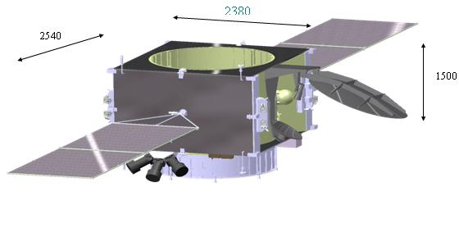

Figure 7.1 – Appearance of “Kazsat” space system.

The spacecraft "Kazsat", placed in geostationary orbit, carries out communication and television broadcasting through 12 transponders, covering the entire territory of the Republic of Kazakhstan and part of neighboring States.

Table 7.1-Main characteristics of "Kazsat" spacecraft

|  |  |
| --- | --- |
| The parameters of the working orbit: |  |
| - orbit type: | Geostationary |
| - inclination: | 0 deg.; |
| - longitude of the standing point (range) | 103º e.l.; |
| " dry " mass | 695 kg |
| Flipping the stock xenon | 60 kg |
| Period of active existence | 10 years |
| Technical resource | 12,5 years |
| Number of relay trunks | 12 |
| The frequency range of the onboard relay complex | Ku |
| The bandwidth of trunks onboard relay complex | 72 MHz |
| Payload mass | 110 kg |
| Rated power consumption of the payload | 1300 W |
| The accuracy of control of the situation and bring you to the point of standing: |  |
| – in longitude | ±0,05 deg. |
| – in latitude | ±0,05 deg. |
| The accuracy of the spacecraft when working onboard relay complex | 0,1 deg. |

Table 7.2-Frequency plan of small spacecraft "KazSat".

|  |  |  |  |  |  |
| --- | --- | --- | --- | --- | --- |
| The transponder number | Central  frequency in  radio link  up, MHz | Central  frequency in  radio link  down, MHz | The working bandwidth of thetransponder,  MHz | Polarization in the radio line up | Polarization in the radio line down |
| K1 | 14041,67 | 10991,67 | 72 | X | Y |
| K2 | 14041,67 | 10991,67 | 72 | Y | X |
| K3 | 14125,0 | 11075,0 | 72 | X | Y |
| K4 | 14125,0 | 11075,0 | 72 | Y | X |
| K5 | 14208,33 | 11158,33 | 72 | X | Y |
| K6 | 14208,33 | 11158,33 | 72 | Y | X |
| K7 | 14291,67 | 11491,67 | 72 | X | Y |
| K8 | 14291,67 | 11491,67 | 72 | Y | X |
| K9 | 14275,0 | 11575,0 | 72 | X | Y |
| K10 | 14275,0 | 11575,0 | 72 | Y | X |
| K11 | 14458,33 | 11658,33 | 72 | X | Y |
| K12 | 14458,33 | 11658,33 | 72 | Y | X |
| Маяк | - | 11199,5 | - | - | R |

The dimensions of the service area are shown in figure 7.2. The service area is provided by a combined receiving and transmitting antenna with a radiation pattern of 2.5 x 3.6 deg., formed by a two-mirror system with a profiled main mirror.

Republics of Central Asia, Caucasus, Central parts of the Russian Federation, including the Moscow region fall into the zone of confident reception of the satellite signal.

Table 7.3 - Results of calculations of EIRP and quality factor of the onboard relay complex spacecraft "KazSat" according simulation.

|  |  |  |  |  |  |  |
| --- | --- | --- | --- | --- | --- | --- |
| City | EIRP, dBW | | | Q-factor, dB/K | | |
| By TS | calculated | stock EIRP | By TS | calculated | quality factor |
| Astana | 51,50 | 52,97 | 1,47 | 4,30 | 8,74 | 4,44 |
| Almaty | 49,05 | 52,15 | 1,65 | 3,30 | 7,29 | 3,99 |
| Aktau | 50,50 | 51,03 | 0,53 | 3,30 | 6,50 | 3,20 |
| Petropavlovsk | 50,50 | 52,23 | 1,73 | 3,30 | 8,50 | 5,20 |
| Karaganda | 52,50 | 52,97 | 0,47 | 5,30 | 8,75 | 3,45 |
| Ust-Kamenogorsk | 50,50 | 52,76 | 2,26 | 3,30 | 9,15 | 5,85 |

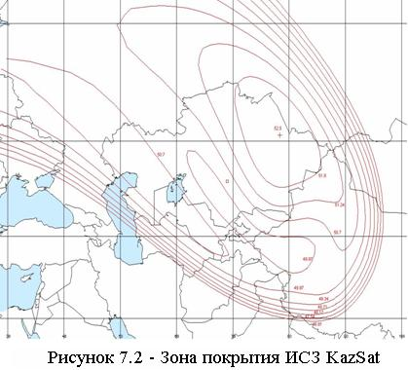

KazSat is intended for organization of TV and radio broadcasting channels, telephone communication, data transmission, broadband Internet access, creation and development of VSAT networks, creation of departmental and corporate communication networks, provision of multimedia services package.

7.2 Ground control complex

Navigation of the KazSat satellite will be carried out in the ground-based spacecraft control complex (GCC), which is located one hundred kilometers from Astana in the city of Akkol, Akmola region. The total area of the GCC is 6 916 sq km, while the most up-to-date equipment corresponding to the world standard. The GCC consists of three main divisions – the monitoring center, the control center and the payload Department.

Ground control complex (GCC) and communication monitoring system on the territory of the Republic of Kazakhstan provide the solution of problems of control, control and maintenance of the specified characteristics of the spacecraft at the stage of its regular operation. The scheme of functioning of GCC "Kazsat" IS shown in figure 7.3.

**Lecture № 15 Losses due to refraction and antenna guidance inaccuracy.**

Refraction is the curvature of the signal path as it passes through the atmosphere (ionosphere and troposphere).

Ionospheric refraction (in degrees) can be determined by the formula:

from which it follows that it is inversely proportional to the square of the frequency and becomes negligible at f > 5 GHz. Tropospheric refraction is frequency independent. For a standard atmosphere at small elevation angles, the constant (regular) component of tropospheric refraction (in degrees)*.*

Full refraction shown in figure 5.16.

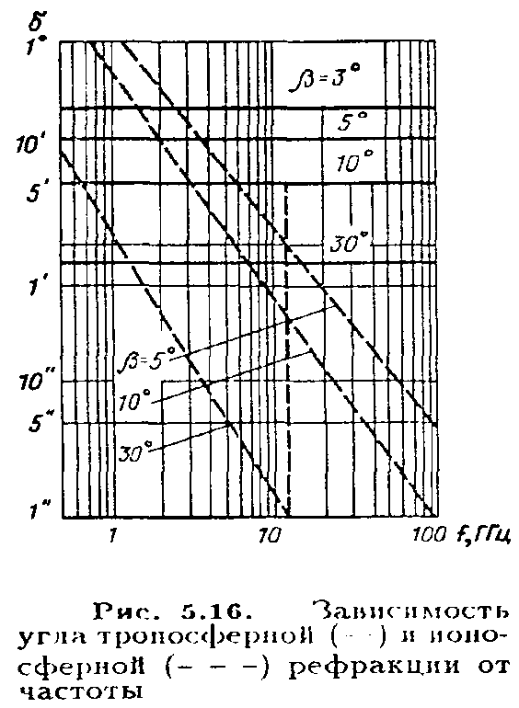With automatic guidance antennas but the maximum incoming signal refraction effect is virtually eliminated. Another component of losses-due to the inaccuracy of pointing antennas of earth stations on the satellite-is determined by the angular deviation of the axis of the main lobe of the radiation pattern from the true direction of the satellite, as well as the width and shape of the lobe. Usually use one of the following approximations of the shape of the diagram within the main part of the main lobe: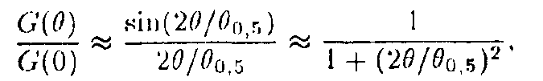

Where **- is the width of the antenna pattern in terms of half power. Then loss of guidance



In modern guidance systems, antenna control is usually carried out on two axes (for example, azimuthal and angular). The angular error of guidance on each of the axes can be represented by the sum of the three components:

Where **-angular error due to imperfections of the mechanical part of the system (backlash gears and mirror deformations); — fluctuation error due to the influence of noise in the tracking channels;  - dynamic (speed) error due to the movement of the antenna during tracking.;

The first component depends on the design of the antenna and is usually specified in the passport data; its statistics are not given; the second is calculated by the expected signal-to-noise ratio in the reception channels and has a Gaussian distribution with parameters ; the third depends on the speed of the relative movement of the satellite relative to the ground point where the antenna is located, and can be determined by solving the equation

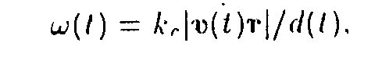

where kc is the transmission coefficient of the tracking channel; v is the speed of the satellite in space; r is the unit radius vector; d is the distance to the satellite (inclined range).

This equation is solved in the calculation of target designations for earth stations of the system**, so it is enough to carry out statistical processing of these target designations for several earth stations of the system. The results of such processing performed for the “Molniya-3” and “Ekran” satellites show that the highest velocities of “Molniya” satellites do not exceed 0.2 deg/s, and for geostationary satellites they are less. The distribution  is close to Gaussian, respectively the probability density of the angular guidance error in each plane



Expressions (5.15) and (5.16) allow to calculate the value and probability density of the guidance error for each of the axes. The total error of guidance in the picture plane is determined by a known rule

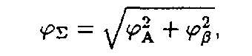

and the error probability density obeys Rayleigh's generalized law

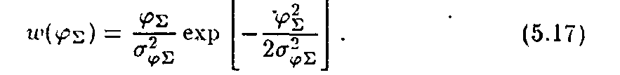

Phase effects in the atmosphere

The Faraday effect and the consequent consequence — the phase dispersion of signals-are associated with the influence of the atmosphere. As is known, the Faraday effect is due to the fact that when a linearly polarized wave propagates through the atmosphere under the influence of the Earth's magnetic field, this wave splits into two components that propagate in the ionosphere at different speeds. Consequently, between them there is a phase shift, which leads to the rotation of the polarization plane of the total wave.

Under some simplifying propositions the rotation angle of the polarization plane



The results of calculations of this formula for several values of frequency and antenna angles are shown in table. 5. 4, from which it follows that the Faraday effect leads to a noticeable change in the direction of the polarization vector at frequencies below 5 GHz; at frequencies above 10 GHz, this phenomenon can not be considered.

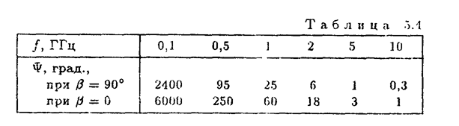

The effect of this effect is that when used to communicate signals with linear polarization, signal losses will occur between collinear antennas (transmitting and receiving) in order to avoid this at frequencies below 10 GHz, satellite systems use only circular polarization; in higher frequency ranges, phase effects do not prevent the use of linear polarization.

Phase effects in the atmosphere, more precisely their frequency-dependent characters, lead to phase dispersion of the components of the transmitted signals and, consequently, to their distortion at reception. Like Faraday rotation, the degree of influence of these effects is inversely proportional to the square of the frequency. Total phase shift of the signal, where n is the refractive index of the atmosphere; C is the speed of light; — the group delay time of the signal.

The approximate value of the difference of the group delay time - for the extreme components of a broadband signal with a band should be such that there is no distortion of the transmitted signals . To quantify the broadband atmosphere we take . Then. The results of calculations for this formula are shown in table. 5.5, which implies that the largest band of signal that can be transmitted through the atmosphere without phase distortion is approximately 25 MHz in the 1 GHz band and increases to 270 MHz in the 4 Band.. .6 GHz.

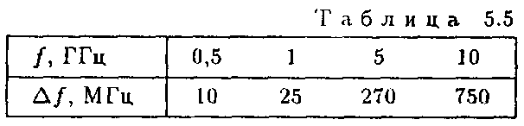

These limitations should be kept in mind when designing broadband TV and TLF lines, especially in the frequency ranges below 4 GHz.